



SCOPE OF work

consultant as teamleader of Biodiversity AND SNARE baseline survey in Year 2 IN QUANG NAM PROVINCE

Background
USAID Biodiversity Conservation is a 5 year-project starting from July 2020 to June 2025. The USAID Biodiversity Conservation project (the Project) aims to maintain and increase forest quality and protect and stabilize wildlife population in high conservation value provinces (Ha Tinh, Lam Dong, Ninh Binh, Quang Binh, Quang Nam, Quang Tri, and TT Hue). The program targets 14 special use forests (SUFs) and 07 protection forests (PFs), linking forest management units across the landscape to maintain forest cover and connectivity of habitats vital for the protection of Vietnam’s threatened and endemic species. The Project is implemented by WWF US and WWF-Viet Nam in collaboration with the Project’s partners Leibniz-Institute for Zoo and Wildlife, Re:wild, the International Union for the Conservation of Nature Vietnam, Education for Nature Vietnam, and Flora and Fauna International.
The USAID BC project has four strategic approaches (SA):
- SA1: Promote Conservation-Friendly Enterprises in Forest Dependent Communities.
- SA2: Strengthen Management of Special-use and Protection Forests.
- SA3: Increase Functionality of Law Enforcement Systems for Forest and Wildlife Crimes.
- SA4: Reduce Local Demand Through Behavior Change Methodologies.
Camera-trapping is a non-invasive survey method that allows for the rapid collection of large amounts of wildlife data in remote areas with minimal effort. Once camera-traps are set up, they will operate without the researcher being present. This method has become popular in monitoring terrestrial wildlife and is well suited for detecting rare, mysterious or rare species. To monitor biodiversity, the project needs a survey design that was both feasible and reproducible and do not target any particular species, but maximize the opportunity to capture a representative picture of the wild species community. Camera-traps are particularly suitable for providing a balanced view of mammal populations, as the camera-traps capture images of all animals larger than approximately 500 grams that move in front of the camera's sensor. Thus, a standard camera-trap set up can not only provide information about the distribution of certain taxa, but can also provide information about populations of wildlife, such as occupancy index of species. The planned iteration surveys under the USAID Conservation of Biodiversity project will allow conservation scientists to assess trends in variability over time and thus provide an important indicator if conservation interventions and management decisions in this project are successful. During the second year, the activity of Biodiversity Survey by Systematic Cameratrap and Snare Baseline Survey in Quang Nam province will be conducted at 2 Forest Management Board (Table 1).
Table 1. The sites for systematic camera-trap and snare baseline survey in Year 2 – QUẢNG NAM province
Province | Protected Area/Protection Forests | Implemented in Year 2 | Camera-trap location/Station | Conducted by
Quảng Nam | Elephant SHCA
Quảng Nam | Sao La Quang Nam SHCA
Quảng Nam | Sông Thanh National Park
Quảng Nam | Tay Giang PFMB | x | 50 | WWF
Quảng Nam | Đong Giang PFMB | x | 80 | WWF

The Camera traps will be paired to form a trap station consisting of two camera traps. A grid of camera trapping stations over a distance of 2.5 km will be established (Appendix 1). A total of 150 camera trap stations will be established in Quang Nam province in 2022 (Appendix 2). The camera traps will be left in place for at least 2 months. The placement and handling of camera traps will be in accordance with USAID Biodiversity Conservation process and procedures. (See summary in Appendix 3).
Simultaneously with camera trapping, a database will be established to assess the threat of animal snares. The baseline will be established by surveying circular plots with a diameter of 400m surrounding each camera trap station. The location, type and number of snares and other snares will be recorded and all snares will be collected and taken out of the forest (See summary in Appendix 4).
Camera trap and snare data will be recorded using the SMART Mobile app.
The surveys will be carried out by a team of 6-7 people: 01 team leader, 4-5 members of the relevant PFMBs and 1 WWF staff. The team will be supported by two or three (2-3) porters for the first three days (Appendix 5). Teams will be trained in field work processes and procedures and will receive an instruction manual to assist with field work.
The surveys will be conducted according to the schedule established by the two groups from January to June 2022. The USAID Biodiversity Conservation Project in Quang Nam Province is currently recruiting two team leaders. This Scope of Work describes tasks and duties for the position of field team leader.

Purpose and objectives
Purpose of this activity is: (i) to establish and operationally deploy networks of camera trap stations, and (ii) to establish a snare baseline at the target locations. This will be achieved by the following objectives:
Objective 1: Set up and activate camera traps on locations according to the agreed grid design.
Objective 2: Collect and record camera trap data.
Objective 3: Collect and log snare information according to the agreed grid design.

3. TASKS
Under the direction of the VFBC PPMU in Quang Nam, SA 2/3 provincial manager in Quang Nam, SA 2/3 and in close coordination with the Provincial Coordinator of the USAID Biodiversity Conservation project, the Consultants will undertake these tasks:
- Establish a detailed workplan.

First trip
- Conduct technical meetings and trainings to introduce and clarify approach, protocols and procedures to the survey team members.
- Make a detail plan and prepare the survey trip (such as field equipment, batteries, and recruitment of local porters).
- Establish camera trap stations applying the protocols and procedures.
- Select the best positions in each camera trap station to place camera traps for capturing the best photos of wildlife
- Set up camera traps at the stations according to agreed protocol
- Log all required camera trap and snare baseline information.

Retrieval trip
- Conduct a retrieval trip after 60 days, repeat snare baseline collection, and log changes in camera condition if necessary.

At the end of the mission
- Draft a brief and succinct mission report that contains amongst other (i) a spreadsheet as appendix with the locations of each camera trap, and (ii) a map of the camera trap locations. Submit together with the report the data of SMART Mobile for the snare baselines. Report, appendices and SMART data will follow templates provided by the Project.

4. DELIVERABLES
 | Deliverables | Tasks included | Qty | Before | Form
I | Workplan | 1 | 1 | Not later than one week after the start of the assignment | Electronic by email. In Vietnamese
II | Report on Technical meetings/trainings; a detail plan for survey trip | 2, 3,4 | 1 | Not later than three weeks after the start of the assignment | Electronic by email. In Vietnamese
III | Map with camera trap station locations | 5, 6,7 | 1 | Not later than 4,5 month after the start of the assignment | Electronic by email. In Vietnamese.
IV | Mission report | 8,9 | 1 | Not later than 7 months afer the start of the assignment | Report in Vietnamese.

5. NUMBER OF WORKING DAYS (Estimated)

 | Month/2022
Teamleader | 1 | 2 | 3 | 4 | 5 | 6 | 7 | 8 | 9 | 10 | 11 | 12 | Tổng
Teamleader 1 |  | 16 | 23 | 21 | 15 |  |  |  |  |  |  |  | 75
Teamleader 2 |  | 16 | 23 | 21 | 24 | 21 | 14 |  |  |  |  |  | 118

6. PROFILE

General qualifications and skills
- A degree in forestry, natural resource management, biology, or other relevant subject.
- Working proficiency in spoken and written English is an advantage.
- Basic knowledge of principles of scientific data collection and statistics.

General professional experience
- At least five years working in natural resource management.
- Demonstrable working experience with local people, management boards of SUFs/ PFs in Vietnam.

Specific professional experience

Mandatory
- At least two-year working experience in systematic camera trapping.
- Demonstrable experience with SMART (version 6.3.1) data collection and management.
- At least two years of experience with conducting surveys in forests using GPS.

Preferred
- Experience with wildlife conservation, camera trapping in Viet Nam, and an understanding of the local context.
- Experience with systematic camera trapping photo and data management.
- Experience with GIS software (Mapinfo, QGIS, ArcInfo).

7. CRITERIA FOR ASSESSMENT
Criteria | Maximum Score
1. Qualification | 10
- University | 7
- Post graduated | 10
2. Related Experience | 70
2.1. No of years working in systematic camera trapping | 30
- <3 years | 20
- 3-5 years | 25
- > 5 years | 30
2.2. No of years working in SMART | 30
- > 2 years | 20
- 2-5 years | 25
- > 5 years | 30
2.3. Teamleader | 10
- Has been a teamleader of a BD survey team | 10
- Has been a member of BD survey team | 5
3. Other skills | 20
- Mapinfo, QGIS, ArcInfo | 5
- Experience in systematic camera trap photo management | 5
- Making report in English | 5
- Experience in Wildlife conservation in Vietnam and understanding of local context | 5
Total | 100
CRITERIA for Quality and Cost Evaluation of proposal/bidding document
- Proposed weights for the technical evaluation: 100 points (see above table). The minimum score that the consultant will be considered as a qualified consultant for this assignment is at least 70 points.
- The weightings of Technical and Financial Proposals are 80% and 20% respectively.

Camera trap grid
Figure 1 Example of systematic grid (2.5 km x 2,5 km) of camera-trap stations
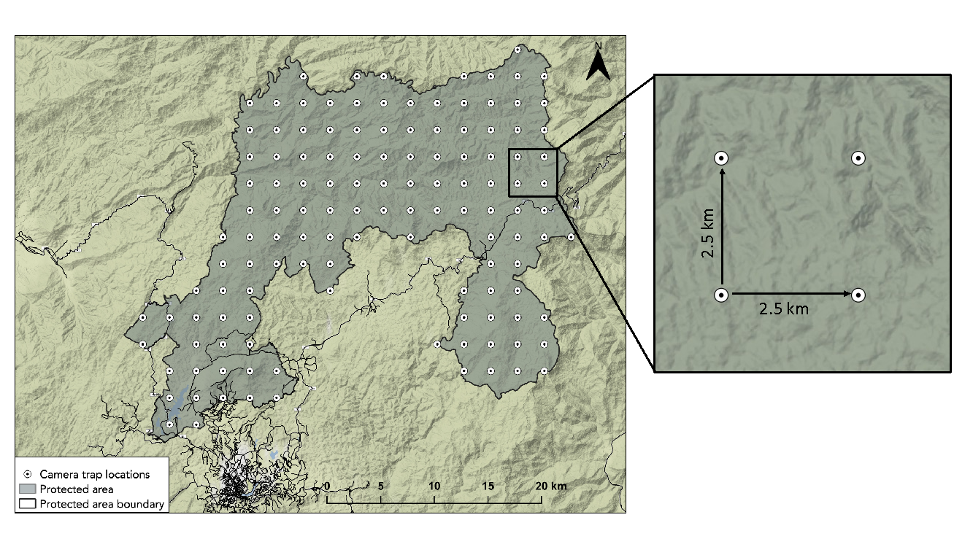
Figure 2 Example of a ‘block’ of 6 camera trap stations (12 camera traps)
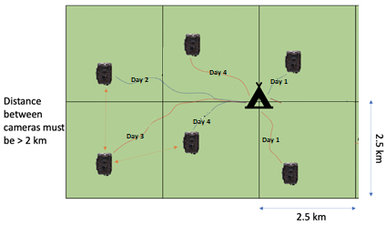

SURVEY METHODS
3.1. METHODS OF CAMERA-TRAP (SUMMARY)
• A systematic grid of points 2.5 km apart has been established; This separation distance is considered large enough that the image traps can function independently for most species (IZW, pers. comm.). See figure 1.
Figure 1. Example of proposed coarse grid (2.5 distance) camera-trap locations in a PA located in the south of the Annamites, inside USAID project area.
• Inaccessible camera-trap locations will be removed from the survey design (i.e. rocky areas or hard to reach areas).
• Two camera traps will be deployed as close as possible to each intended point (<500 m), with the final position determined to maximize the probability of species detection; a minimum distance of 2 km between trapping locations will be maintained (as recommended by IZW); two camera traps per location is believed to be an effective sampling strategy when locations are difficult to access.
• Camera traps will be placed in the forest for about 2 months at each site. See figure 2.
• Data will be managed using a combination of logical directory structure (Camera trap location → Camera trap → Photos) and metadata tags.
• Analysis will be performed in R software, using a combination of packages running on R software: camtrapR, unmarked and runjags.
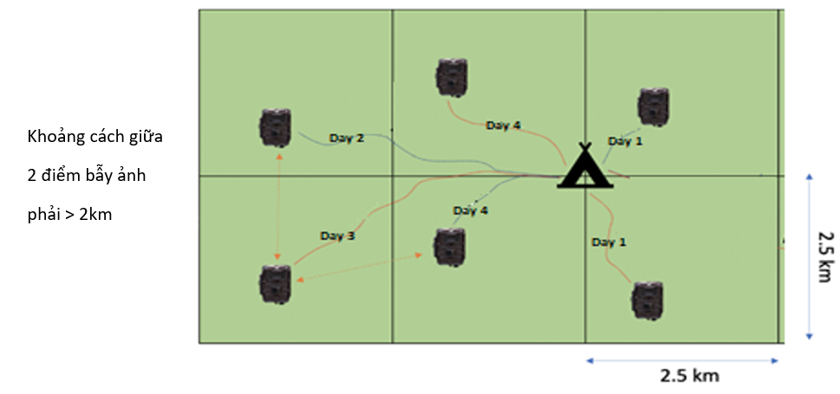
Figure 2. Outline diagram of each "block" of trapping survey of 6 trap points (2 traps at each point, which means a total of 12 traps/6 points)

ANNEX 2: MAP OF CAMERA TRAP STATIIONS AND PLAN OF SURVEYS
  - Map of Camera Trap station in Dong Giang PFMB
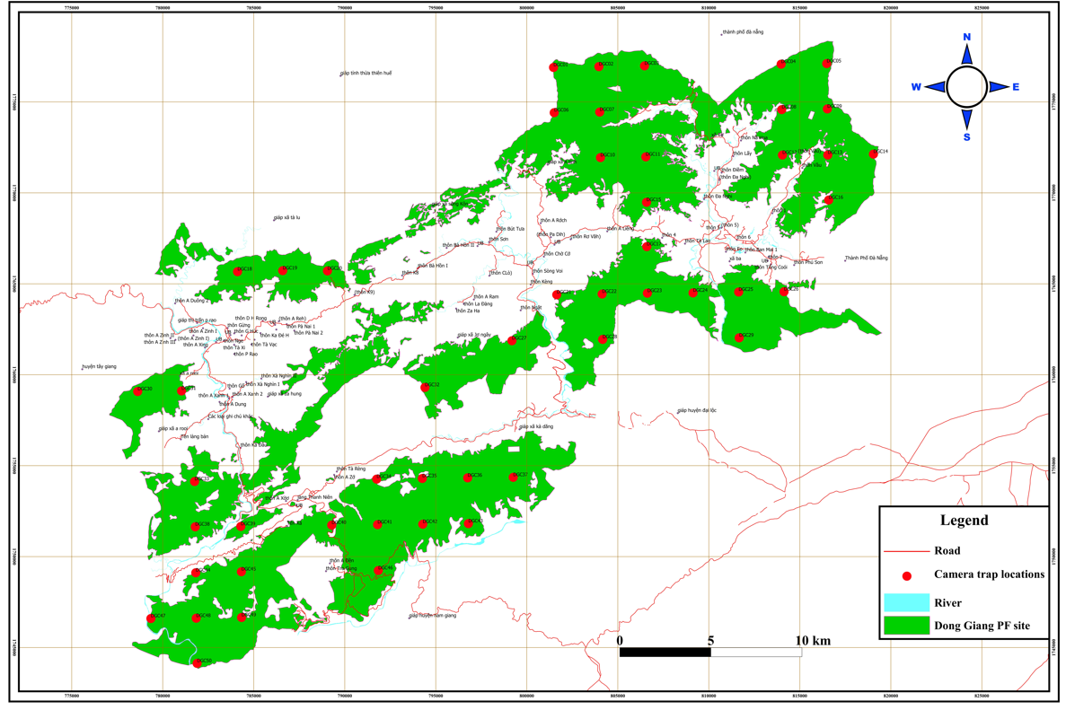
Hình 7. Bản đồ điểm bẫy ảnh đề xuất tại RPH Đông Giang

b. Plan of survey in Dong Giang PFMB
Activities | 2022
Activities | 1 |  |  |  | 2 |  |  |  | 3 |  |  |  | 4 |  |  |  | 5 |  |  |  | 6 |  |  |  | 7 |  |  |  | 8 |  |  |  | 9
 | 1 | 2 | 3 | 4 | 1 | 2 | 3 | 4 | 1 | 2 | 3 | 4 | 1 | 2 | 3 | 4 | 1 | 2 | 3 | 4 | 1 | 2 | 3 | 4 | 1 | 2 | 3 | 4 | 1 | 2 | 3 | 4 | 1 | 2 | 3 | 4
1. Prepare and training |  |  | X
2. Field trip 1 (2 teams) – setting up camera trap and Snare baseline survey in 12 camera trap stations |  |  |  |  |  | X | X
3. Field trip 2 (2 teams) – setting up camera trap and Snare baseline survey in 12 camera trap stations |  |  |  |  |  |  | X | X
4. Field trip 3 (2 teams) – setting up camera trap and Snare baseline survey in 12 camera trap stations |  |  |  |  |  |  |  | X | X
5. Field trip 4 (2 teams) – setting up camera trap and Snare baseline survey in 14 camera trap stations |  |  |  |  |  |  |  |  |  | X | X
6. Field trip 5 (2 teams) – Retrieving camera trap and Snare baseline survey in 12 camera trap stations |  |  |  |  |  |  |  |  |  |  |  |  |  | X | X
7. Field trip 6 (2 teams) – Retrieving camera trap and Snare baseline survey in 12 camera trap stations |  |  |  |  |  |  |  |  |  |  |  |  |  |  | X | X
8. Field trip 7 (2 teams) – Retrieving camera trap and Snare baseline survey in 12 camera trap stations |  |  |  |  |  |  |  |  |  |  |  |  |  |  |  | X | X
9. Field trip 8 (2 teams) – Retrieving camera trap and Snare baseline survey in 14 camera trap stations |  |  |  |  |  |  |  |  |  |  |  |  |  |  |  |  |  | X | X
10. Data analysis |  |  |  |  |  |  |  |  |  |  |  |  |  |  |  |  |  |  |  |  | x | x | x | x
11. Report |  |  |  |  |  |  |  |  |  |  |  |  |  |  |  |  |  |  |  |  |  |  |  |  |  |  |  |  | x | x | x | x

  - Map of Camera Trap stations in Tay Giang PFMB
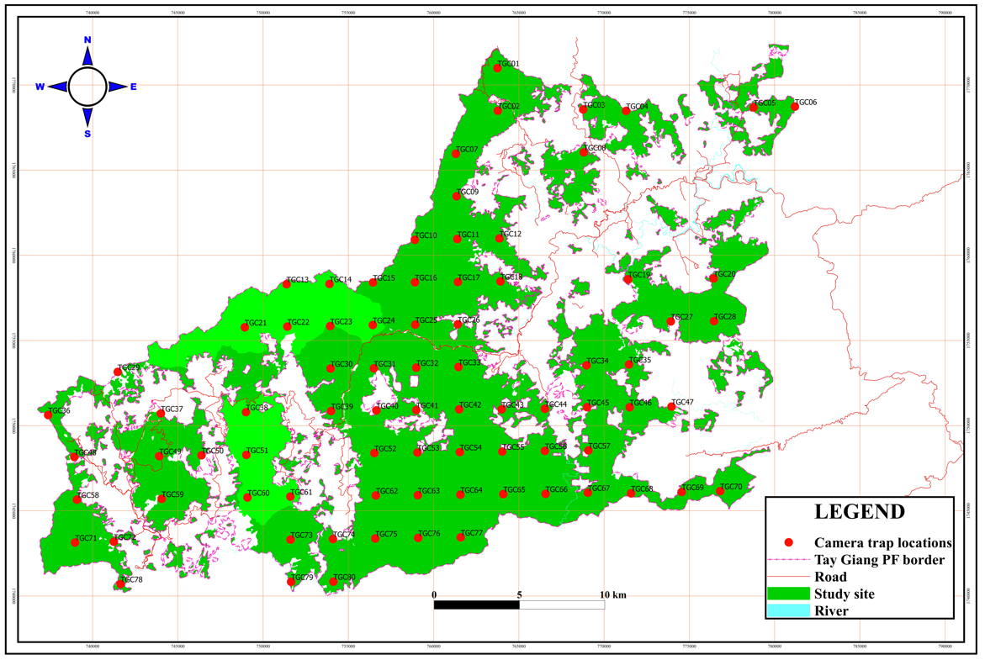
Hình 8. Bản đồ điểm bẫy ảnh đề xuất tại RPH Tây Giang

Plan for surveys in Tay Giang PFMB
Activities |  |  |  |  | 2022
Activities | 1 |  |  |  | 2 |  |  |  | 3 |  |  |  | 4 |  |  |  | 5 |  |  |  | 6 |  |  |  | 7 |  |  |  | 8 |  |  |  | 9
 | 1 | 2 | 3 | 4 | 1 | 2 | 3 | 4 | 1 | 2 | 3 | 4 | 1 | 2 | 3 | 4 | 1 | 2 | 3 | 4 | 1 | 2 | 3 | 4 | 1 | 2 | 3 | 4 | 1 | 2 | 3 | 4 | 1 | 2 | 3 | 4
1. Prepare and training |  |  | x
2. Field trip 1 (2 teams) – setting up camera trap and Snare baseline survey in 16 camera trap stations |  |  |  |  |  |  |  |  |  |  | x | x
3. Field trip 2 (2 teams) – setting up camera trap and Snare baseline survey in 14 camera trap stations |  |  |  |  |  |  |  |  |  |  |  |  | x
4. Field trip 3 (2 teams) – setting up camera trap and Snare baseline survey in 12 camera trap stations |  |  |  |  |  |  |  |  |  |  |  |  |  | x | x
Field trip 4 (2 teams) – setting up camera trap and Snare baseline survey in 12 camera trap stations |  |  |  |  |  |  |  |  |  |  |  |  |  |  |  | x
Field trip 5 (2 teams) – setting up camera trap and Snare baseline survey in 12 camera trap stations |  |  |  |  |  |  |  |  |  |  |  |  |  |  |  |  | x | x
7. Field trip 6 (2 teams) – setting up camera trap and Snare baseline survey in 14 camera trap stations |  |  |  |  |  |  |  |  |  |  |  |  |  |  |  |  |  | x | x
8. Field trip 7 (2 teams) – Retrieving camera trap and Snare baseline survey in 16 camera trap stations |  |  |  |  |  |  |  |  |  |  |  |  |  |  |  |  |  |  | x | x
9. Field trip 8 (2 teams) – Retrieving camera trap and Snare baseline survey in 14 camera trap stations |  |  |  |  |  |  |  |  |  |  |  |  |  |  |  |  |  |  |  |  | x | x
Field trip 9 (2 teams) – Retrieving camera trap and Snare baseline survey in 12 camera trap stations |  |  |  |  |  |  |  |  |  |  |  |  |  |  |  |  |  |  |  |  |  |  | x
Field trip 10 (2 teams) – Retrieving camera trap and Snare baseline survey in 12 camera trap stations |  |  |  |  |  |  |  |  |  |  |  |  |  |  |  |  |  |  |  |  |  |  |  | x
Field trip 11 (2 teams) – Retrieving camera trap and Snare baseline survey in 12 camera trap stations |  |  |  |  |  |  |  |  |  |  |  |  |  |  |  |  |  |  |  |  |  |  |  |  | x | x
13. Field trip 12 (2 teams) – Retrieving camera trap and Snare baseline survey in 14 camera trap stations |  |  |  |  |  |  |  |  |  |  |  |  |  |  |  |  |  |  |  |  |  |  |  |  |  |  | x
14. Data analysis |  |  |  |  |  |  |  |  |  |  |  |  |  |  |  |  |  |  |  |  |  |  |  |  |  |  |  |  |  |  | x | x | x
15. Report |  |  |  |  |  |  |  |  |  |  |  |  |  |  |  |  |  |  |  |  |  |  |  |  |  |  |  |  |  |  |  |  |  | x | x | x
16. Consolidate data of Dong Giang and Tay Giang |  |  |  |  |  |  |  |  |  |  |  |  |  |  |  |  |  |  |  |  |  |  |  |  |  |  | x | x | x | x
17. Consolidate report for Dong giang and Tay Giang |  |  |  |  |  |  |  |  |  |  |  |  |  |  |  |  |  |  |  |  |  |  |  |  |  |  |  |  |  |  |  |  | x | x | x | x

Map of 150 camera trap stations in Dong Giang and Tay Giang PFMBs 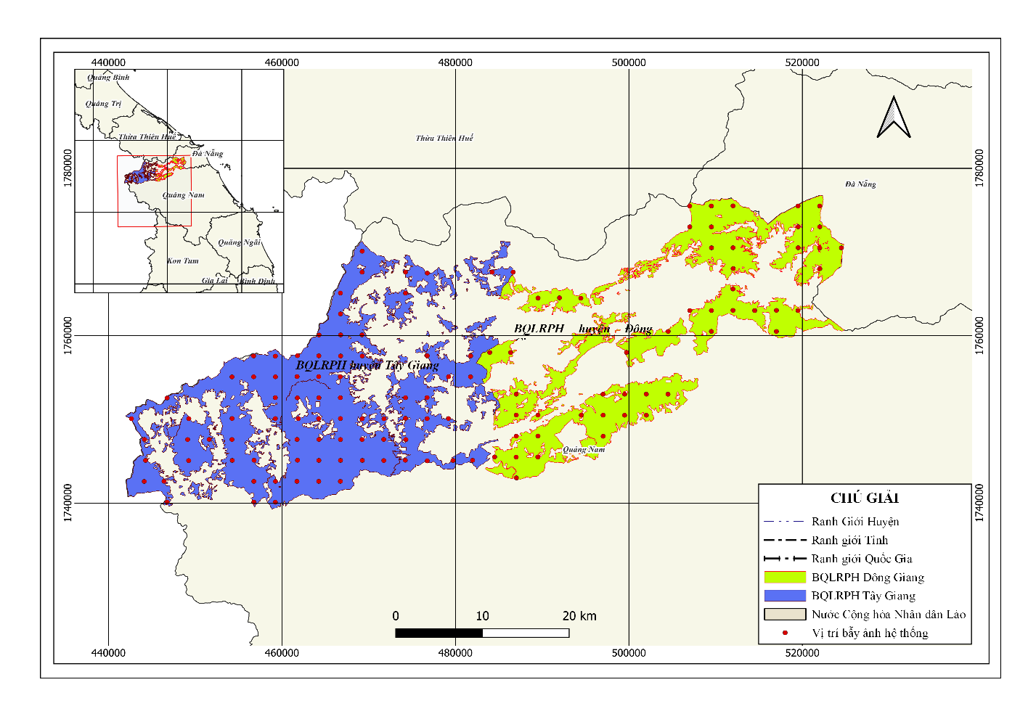

Annex 3. Summary of camera trap baseline collection protocols

Required equipment for setup of camera-traps

Camera traps
Mainly Reconyx white flash cameras will be used. A white-flash model was chosen to facilitate species-level identification, particularly for nocturnal mammal species. Each camera must be labeled with a permanent ID.
It is advised to take at least one spare camera-trap when setting up camera-traps in case a camera malfunctions during the set up.

Battery
High quality AA batteries are required for camera-traps and GPS devices. We recommend using lithium batteries and if these are not available AA Alkaline Energizer batteries. If rechargeable batteries are used, it is important that the batteries are charged and maintained and tested before the set-up.

SD cards
SD cards should be labeled with an ID matching the camera trap ID. Make sure memory card numbers match the camera trap numbers for each unit. Always bring backup memory cards. We recommend a storage capacity of 4Gb or higher.

GPS
Mandatory for navigating and recording the coordinates of camera-trap stations. Make sure all necessary maps and the camera trapping grid are uploaded in your GPS unit. Shapefiles of geodata can be loaded onto GPS devices with software such as GPSMapEdit with cgpsmapper. Important to set up the same projection (e.g UTM48N) for all GPS devices. In the case the GPS is broken/lost and the team need to use other GPSs, please take note of the projection or better adjust the projection to UTM48N before using the GPS.

Digital camera
Used for checking the camera trap setting after taking test photos during camera setup. Alternatively, a smartphone can be used.

Cable lock or bungee cord
To secure cameras.

Padlock
To secure the memory card.

Compass
Used for taking bearing of camera-traps and as security in case there are problems with the GPS.

Camera trap data sheets
To record data in the field.

Camera-trap information sheets
To hold in front of the camera-trap during set up and retrieval (see Arm the camera below and camera trap form)

Machete
To clear vegetation in front of the cameras.

Camera-trap settings
Always check the camera trap settings before placing the camera-trap in the field. Important settings to check include:
- Date/time: Important that date/time is set correct for camera-trap data management.
- Only set taking photographs, no recording videos.
- Maximum sensitivity.
- Minimum delay between photographs.
- Taking 5 photographs in a sequence per trigger.

Placing camera traps
The systematic grid-based design should be viewed as a guide for where to place the camera-traps. However, placing each camera-trap at the exact UTM coordinates is not necessary. Small discrepancies between the planned location and the actual site where the camera trap is set will exist and are OK. The final location should be based on practical field conditions and on factors that will maximize detectability.

Per camera trap

Exactly how much leeway is acceptable?
For the survey design with 2.5 kilometers between stations, we recommend setting the camera trap as close as possible and within a 500 meter radius of the planned grid location. When placing cameras, it is also important to remember that there should be a minimum of 2 kilometers between stations. Therefore, moving both neighboring camera-traps 500 meters towards each other, which in our case would decrease the distance between stations to just 1.5 km, should be avoided.

Selection of the camera-trap sites
Once the team is near the planned location, the process of searching for the specific site begins. This process should not be rushed. Exact camera placement is based on a variety of factors. The team should split and carefully search the area for places likely to yield the highest number of wildlife photos. This process involves spending time at each station and careful attention to detail.

Vegetation clearing
Once the camera location has been chosen it is necessary to clear any vegetation that might affect the camera’s performance or the quality of the resulting photographs. Vegetation, including grass and overhanging leaves, can both prevent the camera’s sensor from triggering or can falsely trigger the camera. Furthermore, any obstructions can make it difficult to identify the photographed animal. Vegetation can also reflect the camera’s flash, especially when using infrared units, resulting in whited-out photos.

Adjusting the camera angle.
As mentioned earlier, it is best practice to place the cameras on flat land. However, we recognize that this is not always possible. The most important aspect for camera trap setup is achieving the correct angle of the camera relative to the ground. The camera-traps’ area of highest sensitivity is a straight horizontal plane extending out from the sensor. Therefore, the camera should be angled, or faced up/down so that the sensitive area is parallel with the ground. The simplest way to do this is to angle the camera so that the resulting images are level within the frame and the ground area should cover one-third to half of the images (here it is important to make sure that you have a digital camera to check the photographs). If the ground slopes upwards or downwards perpendicular to the camera this will result in the sensitive area of the camera’s motion sensor to point either down (towards the ground) or up (towards the sky) and a passing animal will not trigger the camera.

“Walk test”
Most cameras will include a test mode during which it is possible to move in front of the camera to test where on the trail an animal will trigger the camera. It is important to remember that most animals are smaller than people and therefore it is essential to crawl, rather than walk, in front of the camera during the test. Note that a person’s face is often the hottest exposed surface on their body, so camera traps will be responding mostly to a person’s head during the ‘walk test’ (emphasizing the need to crawl low down). When the camera-trap is positioned so that the sensor is triggered by movements 1, 3 and 6 meters away from the camera-trap, move on to the next step.

Recording additional data about the set up
Note in the camera-trap data sheet (see Appendix) the bearing of both camera-traps, the height of both camera-traps the distance to the trail/game trail road, and the type of trail.

Arm the camera-trap
Turn the camera-trap on. Lock the camera-trap. Fill out the camera-trap information sheet (Set up, see Appendix). Write down the station ID, camera-trap ID, date, and time on the sheet. Hold the sheet in front of the camera-trap and let it take several photographs. Please note that this step should be done just before the team will leave the location.

Retrieval of camera-traps
Camera-traps should stay in the forest at least 60 days. The camera-trap can stay in the forest longer if it is logistically difficult to retrieve them after 60 days (at best no longer than 80 days), but the total study duration should be less than four months in order not to violate the closure assumption. Although data from stations with less than 60 days can be included in the analysis, such a shorter duration will result in lower detection probabilities, which might result in missing rarer species.
When retrieving a camera, make sure that you walk in front of the camera-trap so that you trigger the camera-trap to ensure that it is still functional. Fill out the camera-trap information sheet (Retrieval, see Appendix). Write down the station ID, camera-trap ID, date, and time on the sheet. Hold the sheet in front of the camera-trap and let it take several photographs. Then unlock the camera-trap and TURN IT OFF before removing the memory card. Check again that the number on the memory card matches the number on the camera trap. If possible, copy data from the memory card to any device to backup the data in the field. Then put the memory card back in the camera-trap to bring both together to the field house.

Taking canopy photographs & describe the habitat type
Mark in the camera-trap data sheet the basic habitat type found in around the camera- trap station. Use the existing categories.
Take altogether 5 canopy closure photographs around the camera-trap stations. One photo should be taken in the detection zone (3-5 m) of each of the two camera-traps. The remaining three photographs should be taken in a distance of approximately 20 meters from the camera-trap stations’ centre in three different directions, preferable at 0, 120 and 240 degrees. Make sure you point the camera straight up for the canopy photos, holding it directly overhead. If you are standing next to a big tree, move to one side or the other to avoid obstructing the image with a large trunk. If standing in dense vegetation try to get a shot of the higher canopy strata, this should be 3m or higher.

Document any hunting signs close to the camera-trap stations
In case no baseline threat assessment is conducted in parallel to the camera-trapping survey (see PART 2) the teams should note on the camera-trap data sheet (see Appendix) any signs of illegal activity in the vicinity of the camera-trap stations.

Annex 4. Summary of accompanied baseline threat assessment
Each survey team (2 people per team) will intensively search these plots for 60-90 mins, removing all snares (and other types of trap) that they find. All snares that are found will be collected and taken out of the forest, and these data will be collected and managed by SMART software (version 6.3.1), using installed.

SMART data collection
Two SMART surveyors which have been trained in SMART documentation (SMART collection sheet and Snare Survey Collection Sheet – see Appendix or smartphones (i.e Blackview device) with the SMART Mobile/ Connect Apps) and in using a GPS will join each of the biodiversity survey teams. These surveyors exclusively focus on the threat assessment and have no responsibilities for navigation or camera-trapping in the field.
The following three types of overarching illegal activities should be documented:
- People encountered who were recognized as hunters. The patrol team could identify hunters by their equipment, especially guns and traps provide direct evidence of hunting. In addition, carrying live and/or dead animals are also signs of hunting.
- Illegal Camps. Often one camp is used as a base for hunting and logging. Recording camps help to understand more about hotspot for illegal activities.
- Traps
In addition, animals that have been poached or trapped should be recorded. The trap category should further be split in the following three sub-categories:
- Fenced snare lines: A group of snares (generally more than 10) in a line with small fence that is set up to push animals towards the snares.
- Single/few snares without a fence: A single recorded snare or a subset of mostly less than 10 snares without a fence.
- Other traps: Traps other than snares (i.e. log-fall traps).

2. SMART patrolling while following the biodiversity team to the camera-trap locations
- GPS Waypoints must be set to 001 prior to each patrol
- Turn on the GPS unit at the start of any survey work and keep on until survey work finishes for the day. Ensure your GPS is recording a track log for that day. Set the time interval for recording waypoints during the track log to 5 seconds and set the track log saving by day.
- The two SMART surveyors with two local assistants follow the biodiversity survey team and search for any illegal activities. This includes periodic checks of ridgelines or areas known to be used by poachers for setting snares. The patrol team should try not to slow down the biodiversity team in a considerable way.
- When illegal activities are seen, add a waypoint and document the type of illegal activities (see above) in the SMART Data Collection Sheets. Each day a new data collection sheet will be used.
- Deactivate, remove or destroy snares or other traps.

3. Snare surveys around the camera-trap locations
Once the biodiversity team has reached the final location for the set-up of the camera-traps the patrol team starts an intensive search around for any illegal activities around the location. Important for this intensive search is that SMART surveyors optimize their search based on their field experience to find as many signs of illegal activities (wildlife traps) as possible. In general, the search should be conducted by SMART surveyors in two different sectors (each for one SMART surveyor and one local assistant, within a distance of 200 m from the center point. If SMART surveyors do expect to find traps (e.g. perhaps along ridgelines) in further distance than 200 m from the center point SMART surveyors can deviate from the 200 m radius and extend the search. (Figure 3) The most important thing is to detect as many traps as possible around the camera trap stations.
- The two SMART surveyors are supported each by one local assistant. Each SMART surveyor gets each a GPS and a Snare Survey Collection Sheet.
- Set the time interval for recording waypoints during the track log to 5 seconds.
- At the center of the CT station the two SMART surveyors save the GPS point and document the time. This time is the start time of the intensive search.
- Start the tracklog recording on each GPS.
- From time to time choose “navigate to the waypoint S” (the GPS waypoint saved at the center of the CT station) to check how far away you are from the station mid-point.
- In the first 15-30 minutes of the survey, the two surveyor teams should spread out in opposite directions, on the headings of approximately 0 and 180 degrees.
- After this initial period, surveyor team should try to remain in their own designated sector, but small deviations are acceptable if this increases the number of detected traps.
- Each illegal wildlife activity will be saved as a waypoint in the GPS and the time when the activity was first seen will be noted on the Snare Survey Collection Sheet. It is important for the subsequent analysis that the times are recorded accurately. Save the waypoint and record time before destroying the trap and-or collecting the snare.
- The patrol team searches for 60 – 90 minutes. The time can be adjusted based on the time the camera-trapping team needs for the set-up of the camera-traps and based on the terrain. The aim is to cover a large and representative portion of the 200 m radius plot during the search (not just focus on the surroundings of the cameras). Therefore, it is important that the surveyor teams spread out and search a large part of their sectors, primarily targeting the areas that are most suitable for snaring (based on their experience).
- Save the track log after finishing the search. Use date and station name as file names.
- For each station new Snare Survey Data Collection Sheets will be used (for each of the two surveyor teams) and the camera-trap station ID and the sector/surveyor will be marked on the sheet.
- During the retrieval of the camera-traps (repeated visit) the search radius around the camera- trap locations can likely be increased, as it is expected that the number of recorded threats during the second visit will likely be lower. Important is that the time for the intensive search will remain between 60-90 min.
Figure 3 Threat survey around camera trap stations
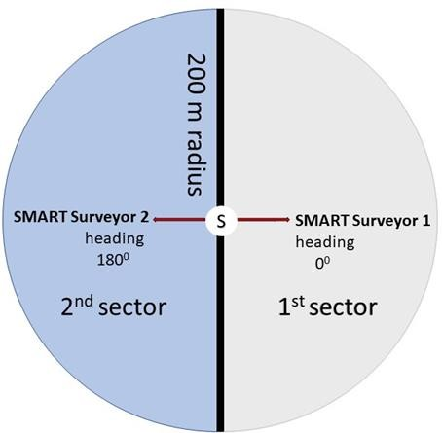

ANNEX 5. Members of team survey

No | Position | Role/main responsibility | Who?
1 | Team leader (1) | - Setting up and retrieving camera-traps  - Trap baseline survey  - Planning in detail for the survey trips  - Writing a report and submitting to the Quang Nam PPMU for comments, revising the report and gaining the acceptance of the report from PPMU (a consultant will be responsible for consolidating data and reports of Dong giang and Tay Giang PFMBs); | Consultant
2 | Supporting and monitoring field technics (1) | - Supporting and monitoring the activities of team on field  - Trap baseline survey  - Recording information at the locations of camera-traps  - Coordinating with the team leader in data management and team equipment management. | WWF staff
3 | Team member (4-5) | - Carrying out activities as assigned by Team Leader, WWF staff;  - Carrying the camera traps from the campsite to the camera-trap locations | Related Pas/PFs staff
4 | Porter (2-3) during the first 2-3 days of the survey | - Carrying food, equipment and tools to the campsite | Local people

