Third Green Economy Green Growth, GEGG Forum
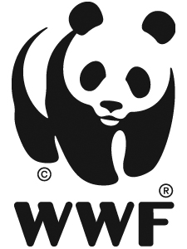
_________________________________________________
Speakers’ Profiles and Event Photographs
Parallel Session 3-3: Making it Work – Energy, Water and Food
Security in a Coherent Strategic Framework
Facilitated by WWF, November 22, 2013, Yangon, Myanmar

Session 3-3 Speakers

Chair: Professor Dr. Khin Ni Ni Thein  President and Founder, Water Research and Training Centre (WRTC) Yangon, Myanmar AIWEB, aiweb.lead@gmail.com  Prof. Dr. Khin Ni Ni Thein is Founder Member and Secretary General of the Academic and Management Board of the Institute for Civil, Earth and Water Engineering in Yangon, Myanmar. She founded and has presided over the Water, Research and Training Centre, a public interest research centre, since 1997. She has 34 years of experience in the water sector, including senior UN management positions. Currently, she is Member of the National Water Resources Committee (NWRC), an APEX body for Integrated Water Resources Management in Myanmar, and Secretary of the NWRC Expert Group. She is a Patron of the Ayeyarwaddy River Basin Research Organisation and is a steering committee member of the Global Water Partnership based in Stockholm. Prof. Thein is Fellow of the ASEAN Academy of Engineering and Technology and joined the Green Economy and Green Growth Convening Group since day one in 2011. Prof. Thein is currently teaching Global Environmental Governance and River Engineering and Integrated Water Resources Management at the Yangon Technological University. She has held a number of responsible positions, from university teaching to Senior Advisor on the UNEP Dams and Development Project, to Chief of the Sustainable Water Management Section, Water Sciences Division in UNESCO-HQ in Paris. She was also Vice President for Development and Resources at Asian Institute of Technology. | 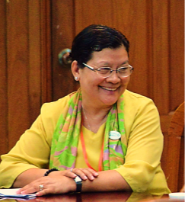
Co-Chair: Michelle Owen  Conservation Program Manager, WWF, Yangon, Myanmar michelle.owen@wwf.panda.org  Michelle Owen has over 10 years of conservation experience in South East Asia. She has worked with WWF for the past 4 years as the Conservation Manager and Acting Country Director in Cambodia, and is currently the Conservation Manager for the new WWF programme in Myanmar. Michelle has led the establishment of a country office, and the strategic development of conservation programs for UK and US international non-government organizations, as well as WWF. Michelle has an academic background in Biology and Geography and has an M.Sc. in Conservation from Imperial College London, UK. | 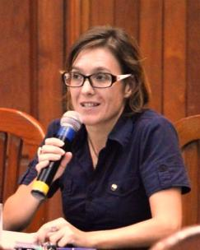

Moderator: Roger Gill, BE. MAICD.  Principal Consultant, Hydro Focus Pty, Ltd., Hobart, Australia roger.gill@hydrofocus.com.au  Roger Gill has over 35 years of experience in the renewable energy sector, particularly in hydropower. He is Principal Consultant in his Hydro Focus Pty Ltd. international consulting business specialising in providing advice on the sustainable development of renewable energy projects and the efficient operation of renewable energy businesses. He has a particular interest in the development of renewable energy in Central and South East Asia, Africa and South America. Roger is Board member of the International Hydropower Association (IHA).  He has a background in Civil Engineering and has undertaken business studies at Harvard Business School. He is a non-executive Director of several corporations in Australia related to renewable energy, irrigation and rail transport services. | 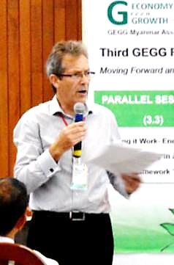
Rex Edward Genato A. Dela Peña  Non-Timber Forest Product (NTFP) Enterprise Development Area Coordinator, NTFP – Exchange Programme, Philippines rdp.pena888@gmail.com / red_pena@yahoo.com  Mr. Dela Peña earned a degree in Industrial Psychology while in college supervising a small scale fabric-based educational toys and furniture enterprise production operation. After working in Pre-need company, he also taught as a Special Education Teacher during his Redemptorist Formation where he was a candidate for MA in Pastoral Ministry at the Inter-Congregational Theological Center (ICTC), Philippines. He also represented the Student Council to the SANDIWAAN Exchange Programme between University of Vienna, Austria and ICTC Formation Centre, Philippines.  From 1998 to 2004 he was the Community Development Officer / Socio-Economic Development Head of the Community Crafts Association of the Philippines / Fair Trade Development. At present, he leads the team in co-establishing and managing enterprise development programs and projects for the centralized marketing and trading system of products for the Forest-based Resources Enterprise Program of Indigenous People’s Federation in the Island of Mindoro and other partner communities. Currently, he is also engaged in Enterprise Development training in and outside Philippines. | 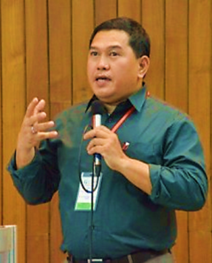

Eoin Sinnott  Director and Proprietor, Tri-Ecos, Ltd., Inhambane, Mozambique sinnotteoin@gmail.com  Mr. Sinnott guides public policy actors to build a landscape conducive to inclusive green growth. He believes transformational change is possible; it’s down to attitude, commitment and communication. He is founder-CEO of Tri-Ecos, a consulting firm that specializes in capturing the value of natural capital for equitable return.  Mr. Sinnott worked with the Government of Mozambique for the African Development Bank to draft the country’s Green Economy Action Plan, approved in October 2013. Prior to this Mr. Sinnott assisted the Government, with WWF’s backing, to write a Roadmap for a Green Economy in 2012 and was an adviser to the President of Mozambique’s delegation at Rio+20.  Between 2006 and 2011 Mr. Sinott was team leader for UN agencies and the Government of Mozambique on micronutrient fortification, urban sustainable energy and tourism initiatives. From 2003 to 2005 Mr. Sinnott managed food security programmes for the UN in Zimbabwe.  Mr. Sinnott graduated with a BA in Business Economics and Social Studies from Trinity College Dublin in 2002 and an MSc in Environmental Management from the School of Oriental and African Studies, University of London in 2010. | 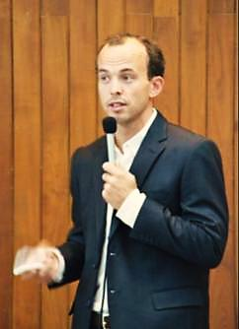

Dr. Maung Maung Than  National Director, RECOFTC, Yangon, Myanmar maungmaung@recoftc.org  Dr. Maung Maung Than has worked for the Forest Department, Forest Resources Environment Development and Conservation Association-FREDA; UNDP (Myanmar); CARE (Myanmar) and Pyoe Pin program of the British Council. Currently he is working as a Country Program Coordinator of RECOFTC-The Center for People and Forests (Myanmar Country Program).  Dr. Maung Maung Than graduated with a B.Sc. in Forestry, University of Yangon, 1985; an M.Sc. in Natural Resources Conservation, Asian Institute of Technology-AIT, Bangkok, Thailand, 1999; and a Doctor of Environment Science, Forest Ecology, Yokohama National University, Yokohama, Japan, 2006. | 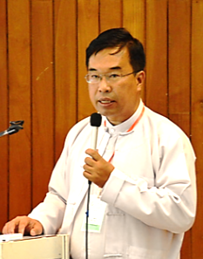
Dr. Rowena Watson  Foreign Affairs Officer, Office of Conservation and Water; Bureau of Oceans and International Environmental and Scientific Affairs; U.S. Department of State, Washington, D.C., USA.  For information: Julien Katchinoff, katchinoffjm@state.gov  Kelly Kryc, krycka@state.gov  Dr. Watson serves in the Bureau of Oceans and International Environmental and Scientific Affairs in the Conservation and Water Office at the U.S. Department of State in Washington DC. She covers a wide range of issues related to bilateral and multilateral natural resources management and conservation policies, focusing on forests, watersheds, timber and wildlife as part of the Forest Team. Dr. Watson has served on multiple U.S. delegations to international environmental conventions and forums. Her current portfolio includes the United Nations Forum on Forests, the Lower Mekong Initiative, big cat conservation (Global Tiger Initiative), and environment issues for Burma/Myanmar.  Prior to working in foreign affairs, Dr. Watson was a laboratory researcher studying zoonotic diseases and bioterrorism. Her education and training include an undergraduate degree in biology from The University of Chicago, doctorate in Animal Sciences-Veterinary Pathology from The University of Maryland, and an American Association for the Advancement of Science (AAAS) diplomacy fellowship with the U.S. Department of State. Dr. Watson now utilizes her scientific background to generate collaborations across disciplines and emphasize the roles for science in policy making and sustainable development. | 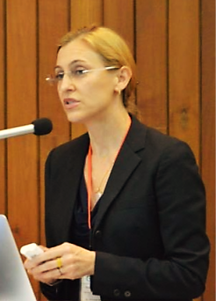
Cameron Ironside  Program Director, International Hydropower Association (IHA), Auckland, New Zealand ci@hydropower.org  Mr. Ironside joined the International Hydropower Association (IHA) in February 2010 as Program Manager. Cameron left a commercial legal career in South Africa to complete an MBA (2009) at the University of Edinburgh, tailored to focus on climate change and renewable energy. Mr. Ironside directs the IHA work program on sustainability and leads the roll out of the Hydropower Sustainability Assessment Protocol worldwide. | 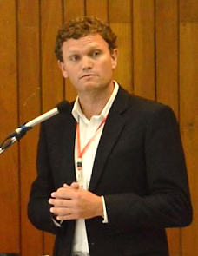

Dr. Andrea M. Bassi  Founder and CEO, KnowlEdge Srl. andrea.bassi@ke-srl.com  Dr. Bassi is the founder and CEO of KnowlEdge Srl. and an Extraordinary Professor at Stellenbosch University, in South Africa. Dr. Bassi is a project leader and researcher with over 10 years of experience, supporting more than 20 governments and several international organizations, primarily on green economy strategies and scenarios, climate mitigation and adaptation, and sustainable development. Dr. Bassi holds a Ph.D. and M.Phil. in System Dynamics from the University of Bergen, Norway, a M.Sc. in Business and Economics from LIUC, Italy, and a postgraduate course in modeling the environment at the Universitad Politecnica de Catalunia in Spain. | 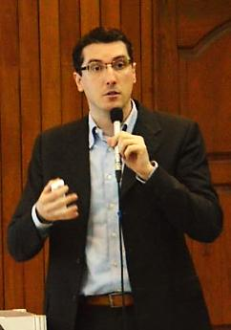

U Aung Myint  General Secretary, Renewable Energy Association Myanmar (REAM), Yangon, Myanmar am.ream@gmail.com  U Aung Myint was the Founder and is currently the General Secretary of a local environmental NGO “Renewable Energy Association Myanmar (REAM)” established in 1995. He was on the teaching staff and was a Research Scholar at the Departments of Botany, Marine Biology and Marine Science (1972 to 1989) at Yangon and Mawla-myine Universities. He was a Central Committee member of the “Forest Resource Environment Development Association” and is a Life member of ISME “International Society of Mangrove Ecosystems”.  U Aung Myint has been conducting Public Education and Awareness raising functions by implementing demonstration projects to fulfill basic-needs for grassroots (village people); acting as Project Director / Team Leader and Member of Development Programs by networking with the Government, International and Local Organizations and Private Entrepreneurs; and working together with village people who are organized as Community-Based Organization (CBOs) in implementing development projects.  U Aung Myint is a Member of the “National Energy Management Committee” of Myanmar and Member of the “Renewable Energy Working Group” headed by the Ministry of Science & Technology. He is also a Member of the “Village Electrification and Water Supply Committee” headed by the Ministry of Livestock/Fishery & Rural Development; and he is a Member of the Marine Science Post-graduate / Ph.D. Research Steering Committee of the Mawla-myine University. | 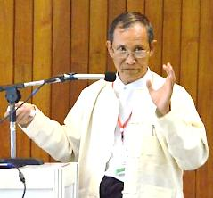
Mr. David Vincent  Head SE Asia Climate Change and Energy Network, UK Foreign and Commonwealth Office, British High Commission, Singapore David.Vincent@fco.gov.uk  Mr. Vincent is Head of the UK Foreign and Commonwealth Office’s South East Asia Climate Change and Energy Network. The Network works with South East Asian countries to promote our shared goal of an ambitious new global climate agreement through the UNFCCC, to explore and explain the implications of climate change for South East Asia, and on low carbon economic development. It also works to promote these objectives through deployment of UK climate finance in the region, funding projects in areas like climate forecasting, energy and forestry. Mr. Vincent worked on climate change and science and innovation during his previous posting to the British Embassy in Moscow. He has an MA from Magdalen College Oxford in Politics, Philosophy and Economics, 1984 -1987. | 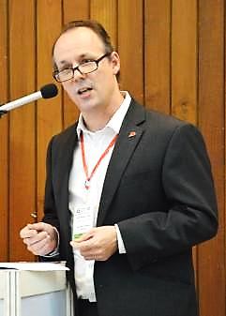

Mr. Ken Tun  Chief Executive Officer, Parami Energy Group of Companies, Yangon, Myanmar, for information, Khin Sabei Phyu khin@parami.biz  Ken Tun is the Chairman and CEO of Parami Energy Group of Myanmar. The group has interest in Oil and Gas, Power, Construction, Banking and Insurance. He received his M.B.A degree from the National University of Singapore and bachelor of engineering degree from Yangon Institute of Technology. Under his capacity as the Chief Executive Officer of Parami Energy Group, he initiated programs to support one third of Monastic schools in Myanmar and to plant 500,000 trees by 2015. He works hard to convince staffs of Parami Energy to take part in group’s disaster relief programs and other social programs such as providing clean water to rural villages and rural hospitals. | 