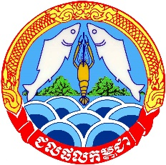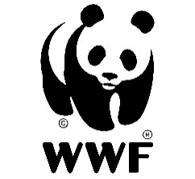

14 May 2022
Joint statement on the loss of an adult Mekong dolphin
Transformative conservation measures are critically needed to save the Mekong dolphins as their continued mortality spark concerns
The Fisheries Administration of the Ministry of Agriculture, Forestry and Fisheries, and WWF are saddened by the loss of an adult male Irrawaddy dolphin, weighing 93kg and 215cm long, that was discovered floating about 36km downstream of the Kampi pool in Kratie province. An examination of the dolphin carcass on 13th May led the members of the Fisheries Administration-WWF’s research team to describe a wound on its tail and a long scratch below its dorsal fin. The research team suggested that the dolphin died about two days ago, but was not able to conclude whether the death was caused by getting caught in fishing net as no mark of gillnet on the dead dolphin body has been observed.
The death of a healthy adult dolphin is especially sad given its currently small population, as this directly affects the breeding potential of the Mekong’s dolphins. The carcass was transferred to the WWF Office in Kratie province, where a continued investigation will take place to determine the exact cause of death.
This is the third adult dolphin that died during the course of first five months this year, where the death of two calves was also recorded. Despite the ban of the use of gillnets in the Mekong habitat by the Royal Government, and while the provincial fisheries cantonments continue to reinforce this ban, entanglement in fishing nets continues to kill the majority of adult dolphin population. It is one of the reasons why senior officials from the national government of Fisheries Administration and WWF staff conducted in early this week law enforcement strategy reviews through a series of meetings with the provincial fishery officials and river guards in Kratie and Stung Treng provinces. Some of immediate measures adopted as a result of the review include strengthening the fisheries management, including dolphin conservation, addressing irregularities, increasing the number of patrols during daytime and nighttime throughout the Mekong habitats in order to conserve the remaining dolphins and protect the River’s mega fish species.
The Mekong Irrawaddy dolphins are fully protected under Cambodia’s Fisheries Law. The population is ranked as critically endangered on the IUCN Red List, the highest international threat ranking for endangered species. The 2020 population census estimated only 89 individuals still swim a 180 km stretch of the Mekong River in Cambodia.
***

