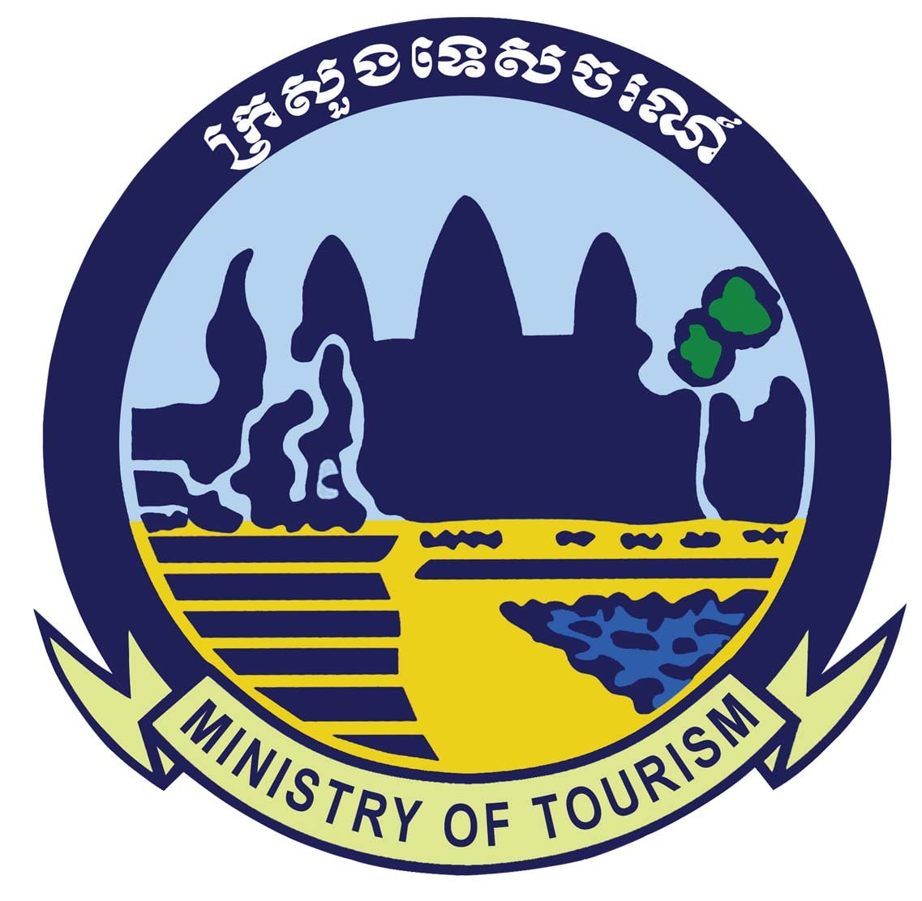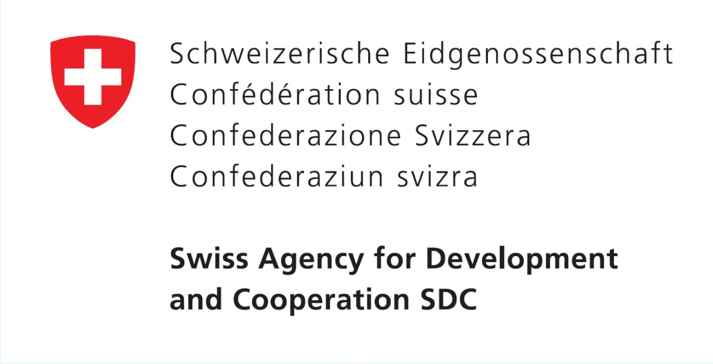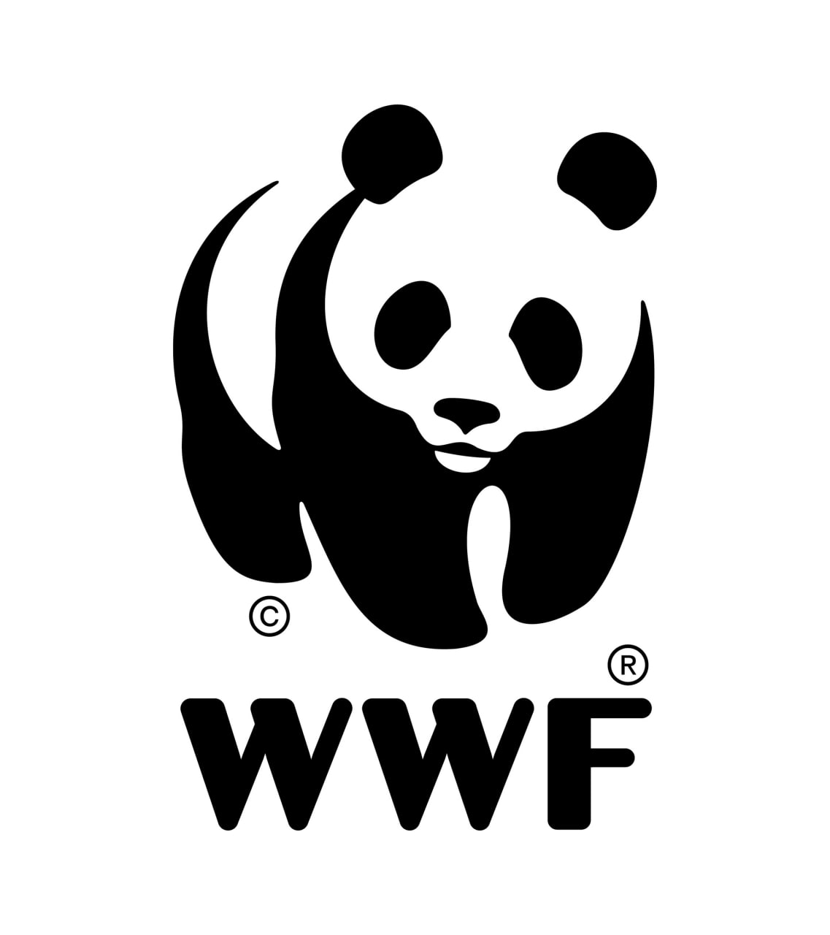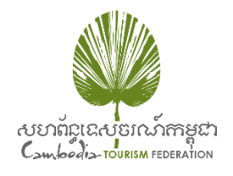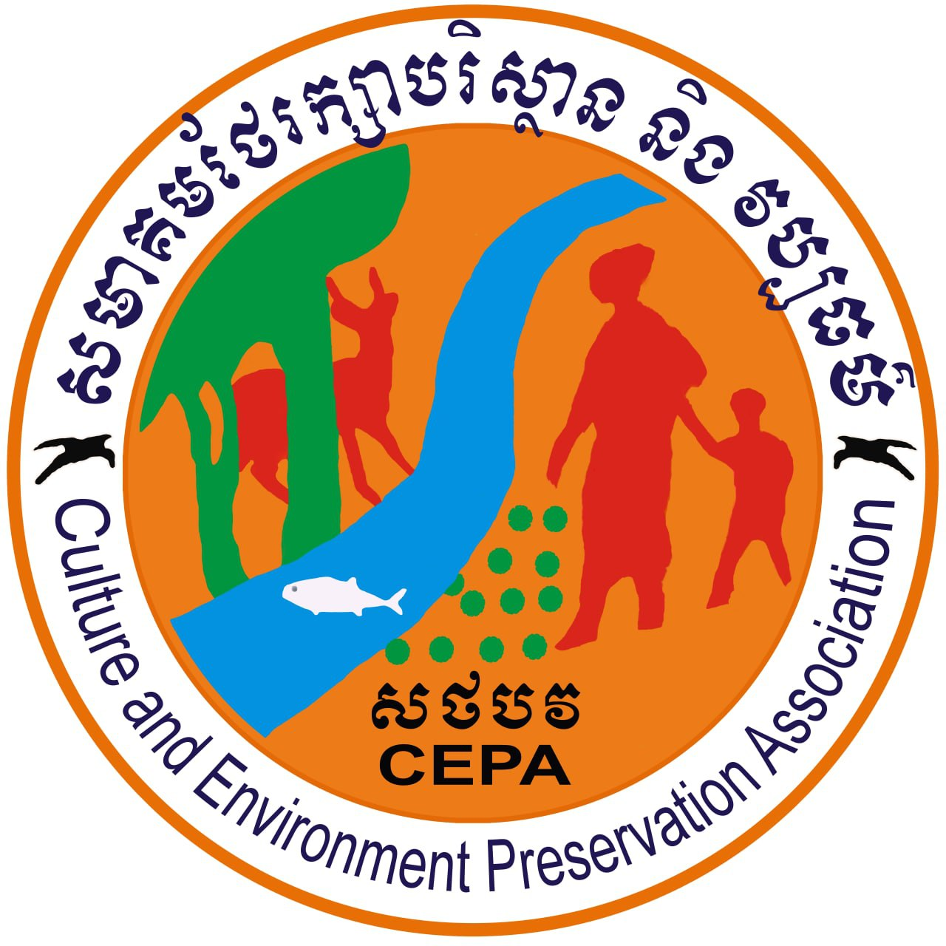
Press Release : For immediate release
Responsible and sustainable tourism key to building back better
Phnom Penh, 14 September 2022 – Tourism recovery from the COVID-19 crisis must integrate the need to increase the industry’s durability and resilience, a commitment to mainstream environmentally-friendly practices to support sustainable tourism. Integrating renewable energy sources like the rooftop solar in the tourism business operations is a win-win both for the environment and tourism operators.
Funded by the Swiss Agency for Development and Cooperation (SDC), the project entitled “Building Back a Climate-Friendly and Inclusive Tourism Sector in Cambodia” was launched today with the goal to facilitate the sustainable energy transition of the Cambodian tourism sector through the adoption of solar and efficient cooling solutions in hotels, eco-resorts, and community-based ecotourism. The project outcome will contribute to Cambodia’s transition to low carbon, low cost and low impact power sector.
“The Ministry of Tourism recognizes the importance of renewable energy development and its contribution to building a sustainable tourism, positioning Cambodia as a green tourism destination,” said His Excellency Kuch Panhasa, Under Secretary of State, Ministry of Tourism.
“I encourage tourism operators, community-based ecotourism groups, and other relevant institutions, to support the implementation of this project, contributing to the effort by the Royal Government of Cambodia in recovering tourism post COVID-19 crisis, as well as developing sustainable and green tourism in Cambodia,” His Excellency Under Secretary of State added.
Tourist and corporate demand for sustainable and responsible tourism is growing and visitors increasingly seek to understand how destinations are managed, and how they can ensure their visit help protect the environment and improve the lives of the people who live there.
Solar and efficient cooling solutions can help tourism operators reduce their operation costs, while increasing the attractiveness of the sector to tourists.
Ms. Nadia Ottiger, Deputy Director of Cooperation / Head of Program Inclusive Economic Development, said that the Swiss Agency for Development and Cooperation (SDC) is delighted to support this initiative, through our long-term partnership with WWF-Switzerland. Both climate protection and climate change adaptation are key priorities for the SDC. “The SDC is committed to long-term climate-compatible development and reducing poverty. We look forward to seeing synergies with other SDC supported projects, such as the Partnership Programme for Forests and Fisheries, and our work on Technical and Vocational Education and Training (TVET).”
“We are excited and inspired by the today’s launch of the ‘build back better’ project, which helps tourism businesses move forward with a more responsible and sustainable practice friendly to the environment by using renewable energy and efficient cooling systems in the eco-lodges, hotels, community-based ecotourism and restaurants. This is a game-changer for the tourism sector in Cambodia,” said Mr. Seng Teak, WWF-Cambodia Country Director.
Designed with sustainable strategies, including a long-term partnership with the Cambodia Tourism Federation (CTF), and local NGOs, such as the Culture and Environment Preservation Association (CEPA), the project has the potential for long lasting impacts on the tourism and energy sectors, that can be replicated at scale. The project will also promote the participation of women and the disabled in the tourism and energy sectors.
“This project will introduce the sustainable energy practice among tourism operators and help our members in reducing their energy bills, through the introduction of solar and energy management, helping them ‘build back better’ after the challenging years of COVID-19,” said Mr. Luu Meng, President of the Cambodia Tourism Federation”.
Through improved facilities and management practice of sustainable energy consumption, it is expected that the income from community-based ecotourism in the Mekong Flooded Forest will increase, creating an incentive for the local communities to reduce the use of unsustainable energy sources and be more actively engaged in biodiversity conservation in the landscape.
-end-
Media contact:
Ms. Sophearoth Ravy, Communications Officer
Tel: 070 409 276 | Email: sophearoth.ravy@wwf.org.kh
Link to photos: https://drive.google.com/drive/folders/1HFDgSLbuSS5bil_-otUBKpUyrmBep7un

