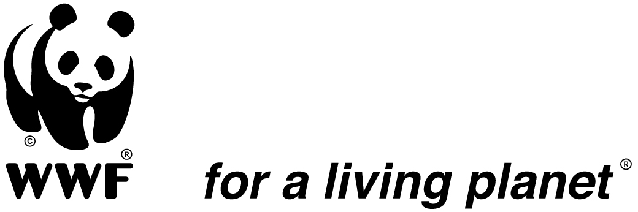
TERMS OF REFERENCE
(Individual Consultant)

Assignment: Procurement Consultancy services

Direct report to: Procurement Specialist, WWF-Viet Nam
Duration: August 2021 – December 2021 (8 hours/day)
Location: Hanoi, Vietnam

I. Background
WWF was one of the first International non-government organizations working in Vietnam. In 1985, WWF began working on a national conservation strategy and since then has worked closely with the Vietnamese Government on a diverse range of environment issues and implemented field activities across the country. Find out more at http://vietnam.panda.org/. WWF recognizes professional consultancy resources are amongst important input to effectively implement its conservation strategies.

II. Major Duties and Responsibilities:
The Procurement Consultant will assist the Procurement Specialist to carry out WWF Viet Nam procurement activities with focus on the following:
- Prepare, publish and distribute procurement opportunities; Issue bidding documents to potential applicants;
- Coordinate the receiving and opening of tender documents;
- Coordinate the evaluation of tenders, organize virtual and direct meetings between evaluation panel members;
- Prepare an evaluation report by compiling assessment of all Evaluation Panel members;
- Prepare and issue rejection, debriefing, award notification letters as required;
- Join in working team to develop and update online procurement tracking system and vendor lists of suppliers and consultants;
- Perform other duties as required by direct supervisor.

III. Profile:

Required Qualifications
- A University degree, preferably in one or more of the following disciplines: business administration, management or business law, Procurement and Supply Chain Management, English language.;
- Good knowledge of MS Office package and office management systems;
- Proven experience as an office administrator, procurement officer/consultant or other related relevant role;
- Familiarity with office management procedures and basic financial/contract management principles.

Required Experience and Competencies
- At least 5 years’ experience working in experience in procurement/purchasing/accounting/ administration related position, preferably in a not-for-profit organization;
- Good communication and negotiation skills;
- Good interpersonal & organizational skills, attention to details, high sense of confidentiality & trustworthy;
- Ability to work in multi-cultural environment;
- Ability to work under pressure to pursue multiple tasks simultaneously;
- Demonstrate high level of integrity;
- Proficiency in English;
- Good computer skills: spreadsheets, word processing, MS Excel, Macro.

IV. Main administrative terms and conditions:

Consultant will arrange himself/herself with necessary office equipment and facilities. WWF-Viet Nam is not responsible to any obligations to fulfil consultant’s health, accident, and social insurance as well as other staff’s ware fare and benefit stipulated by current local labour laws.

V. How to Apply
Qualified and interested candidates are hereby invited to submit his/her proposal which contains the followings:
- Expression of Interest showing availability and readiness to be mobilised within the time-frame set forth in this TOR
- Curriculum vitae dedicated to the assignment, including a list of relevant experience, education background and qualifications required by the TOR.
- Financial proposal indicating consultancy fee (with daily rate)

Application Proposals should be sent to Ms. Phan Thu Hang/Procurement Specialist via hang.phanthu@wwf.org.vn. Application e-mail must have the subject heading indicating "[Name of Consultant] – Procurement Consultant ". Maximum size for electronic submission: 25MB.
Deadline for Proposal Submission: August 4th, 2021 – 17.00 ICT.
Only selected candidate(s) will be contacted about the outcome of their proposals.

