**REQUEST FOR PROPOSAL**

**FOR**

**GALVANIZED IRON WIRE for GABIONS WALLS**

1. **Introduction:**

WWF-Pakistan, under National Competitive Bidding (“NCB”), requires the services of one qualified contractor to provide GI Wire Galvanized.

**2**. **Submission of Bids:**

Bidder shall submit the Technical and Financial Proposals in a single sealed envelope, clearly mentioning the following on the envelope;

* Title of Procurement **GI Wire Galvanized**
* Purchaser Address as mentioned in 2.3

2.1 Only one rate should be quoted for the item and a bidder must avoid giving any alternate quote.

2.2 Quotation must be typed or written in indelible ink and should be signed by an authorized representative. Without a signature on Form of Quotation, the quotation shall not be considered further. All pages of the submitted quotation(s) where entries or amendments have been made, should be signed or initialed by the person signing the quotation.

2.3 A bidder shall submit Price Quotation, on their letterhead, duly signed, stamped by hand on Sealed envelope. The quotation should be addressed and delivered to the following official named official at the address mentioned underneath:

|  |  |  |
| --- | --- | --- |
| Purchaser’s Address | : | **Name: Assad Ullah**  **Designation:** Head of Procurement and Consultancies  World Wide Fund for Nature,  Inside Ali Institute of Education, Ferozpur Road, Lahore  P.O Box 5180 |
| Telephone | : | 0423-5465983 |

**For any queries, please write To:** [**aali@wwf.org.pk**](mailto:aali@wwf.org.pk) and **CC:** [**assadullah@wwf.org.pk**](mailto:assadullah@wwf.org.pk)[**sarehman@wwf.org.pk**](mailto:sarehman@wwf.org.pk)

2.4. The quotation (s) should reach to authorized official at the address indicated hereinabove, by or before **15th September 2025**.

**3. Requirements:**

The Bidder should have a proper business address and office/shop, besides complying with the following eligibility requirements through documentary evidence, to be submitted along with their Quotation:

1. Registration with the Income Tax Department.
2. Registration with Sales Tax Department.
3. Proof of Active Tax Payer of Income & Sales Taxes.
4. The Bidder has their own Manufacturing Plant, having Valid ISO Certifications 9002-14001.

A bidder shall be selected as per the lowest evaluated responsive quotation(s) provided such bidder meets the qualification/eligibility requirements, referred to above.

**4. Additional Documentation:**

Following additional documents are required and would be used for **Technical/ Financial Evaluation**:

1. Signed/Stamped copy of this RFP.
2. Technical proposal of as per Technical Specification/TORs at **Annex-A**
3. Financial proposal with unit rates and total cost of work (Cost must be exclusive of all taxes) as per **Annex-B**
4. Company Profile
5. Willingness to sign the vendor agreement on stamp paper of minimum Rs. 1,500/-
6. Details of Brand/Leaflets/Broachers (If Any)

**5. Validity of Bids:**

Bids shall remain valid for a period of at least **60 days** from the date of submission of the quotation, which may be extended based on mutual discussion. A bid valid for a shorter period may be considered nonresponsive.

**6. Purchaser Right:**

WWF-Pakistan reserves the right to accept or reject any bid, and to annul the bidding process and reject all bids at any time prior to contract award, without thereby incurring any liability to the affected Bidder or bidders. The Purchaser will inform the affected Bidder or bidders of the grounds for the Purchaser’s action, if so requested, but the Purchaser shall not be required to justify the grounds.

6.1 Any bidder, if found engaged in corrupt or fraudulent practices (including collusion/polling will be declared ineligible either indefinitely or for a stated period of time.

6.2 WWF-Pakistan also reserves the right to increase, decrease, delete or modify quantity to be delivered before the issuance of “Purchase/Supply Order” to the “Lowest Evaluated Bidder.

**Regards,**

Assad Ullah

Head Procurement and Consultancies

**Annex-A**

**Technical Specifications/Terms of Reference/BOQs/Designs**

1. Following are the detailed Technical Specification and TORs:
2. GI Wire of # 8 SWG.
3. The wire Should be Hot Dip Galvanized having Zinc Coating ranges from 200g/m2-250g/m2 OR equivalent to (AASHTO M 120) / (ASTM A90).
4. The Wire should be soft enough to be locally assembled by Hands.
5. The tensile strength of the wire shall be in the range of 4000-6000 kg./sq.cm. And shall have an elasticity to permit elongation of the mesh equivalent to minimum of ten (10) % without reducing the gauge or tensile strength of the wire.
6. The Vendor will provide a standard laboratory Test report of the wire. Moreover, WWF will also conduct a test from the relevant Labs to meet the quality assurance and accordingly, the materials will be approved and payment will be processed.
7. The Vendor will tag the weight over each roll of wire.
8. The delivered material should meet the above standards.
9. The delivery of the materials to each respective site, as per stated coordinates, will have to be delivered by the vendor.
10. Some sites may require secondary carriage, cost of which will be borne by the vendor.

**Delivery Schedule:**

|  |  |  |  |  |  |  |
| --- | --- | --- | --- | --- | --- | --- |
| **S.No** | **Activity** | **Region** | **District** | **Village** | **Quantity** | **Coordinates** |
| 1 | Protection Bund | KP | Mansehra | Chitta Batta | 4000 Kg | 34.561063, 73.241474  34.558678, 73.249644 |
| 2 | Protection Bund | KP | Upper Chitral | Moz Gol | 4000 Kg | 36.273393, 72.189647 |
| 3 | Protection Bund | KP | Upper Chitral | Sangalan Dur | 2400 Kg | 36.295548, 72.220502 |
| 4 | Check Dam | KP | Upper Chitral | Phargram | 650 Kg | 36.298035, 72.173247 |
| 5 | Protection Bund & Check dam | KP | Abbottabad | Namli Maira | 2300 Kg | 34.095180, 73.385047 |
| 6 | Protection Bund | KP | Kolai Palas | Haraan | 2200 Kg | 35.054866, 73.034277 |
| 7 | Check dam | KP | Kolai Palas | Shalkhanabad-1 | 1000 Kg | 35.11421667, 73.0261250001 |
| 8 | Protection Bund | KP | Haripur | Beer | 3200 Kg | 34.169681, 72.967515 |

**Annex-I**

**Material for Khyber Pakhtunkhwa KP (WWF- Pakistan)**

|  |  |  |  |  |  |  |
| --- | --- | --- | --- | --- | --- | --- |
| **Sr. No** | **Item Name** | **Specification** | **Unit** | **Quantity** | **Unit Price** | **Total Cost** |
|  | GI wire Hot Dip  **Protection Bund Upper Chitral** | #8 double galvanized Diameter 3.95mm minimum Zinc coating= 250g/m2 minimum Tensile strength= 40kg/mm2 minimum Elongation 10% minimum | Kg | **4000** |  |  |
|  | GI wire Hot Dip  **Protection Bund Upper Chitral** | #8 double galvanized Diameter 3.95mm minimum Zinc coating= 250g/m2 minimum Tensile strength= 40kg/mm2 minimum Elongation 10% minimum | Kg | **2400** |  |  |
|  | GI wire Hot Dip  **Check Dam Upper Chitral** | #8 double galvanized Diameter 3.95mm minimum Zinc coating= 250g/m2 minimum Tensile strength= 40kg/mm2 minimum Elongation 10% minimum | Kg | **650** |  |  |
|  | GI wire Hot Dip  **Protection Bund Mansehra** | #8 double galvanized Diameter 3.95mm minimum Zinc coating= 250g/m2 minimum Tensile strength= 40kg/mm2 minimum Elongation 10% minimum | Kg | **4000** |  |  |
|  | GI wire Hot Dip  **Protection Bund and Check Dam Nathiagali** | #8 double galvanized Diameter 3.95mm minimum Zinc coating= 250g/m2 minimum Tensile strength= 40kg/mm2 minimum Elongation 10% minimum | Kg | **2300** |  |  |
|  | GI wire Hot Dip  **Protection Bund Haripur** | #8 double galvanized Diameter 3.95mm minimum Zinc coating= 250g/m2 minimum Tensile strength= 40kg/mm2 minimum Elongation 10% minimum | Kg | **3200** |  |  |
|  | GI wire Hot Dip  **Protection Bund Kohistan** | #8 double galvanized Diameter 3.95mm minimum Zinc coating= 250g/m2 minimum Tensile strength= 40kg/mm2 minimum Elongation 10% minimum | Kg | **2200** |  |  |
|  | GI wire Hot Dip  **Check dam Kohistan** | #8 double galvanized Diameter 3.95mm minimum Zinc coating= 250g/m2 minimum Tensile strength= 40kg/mm2 minimum Elongation 10% minimum | Kg | **1000** |  |  |

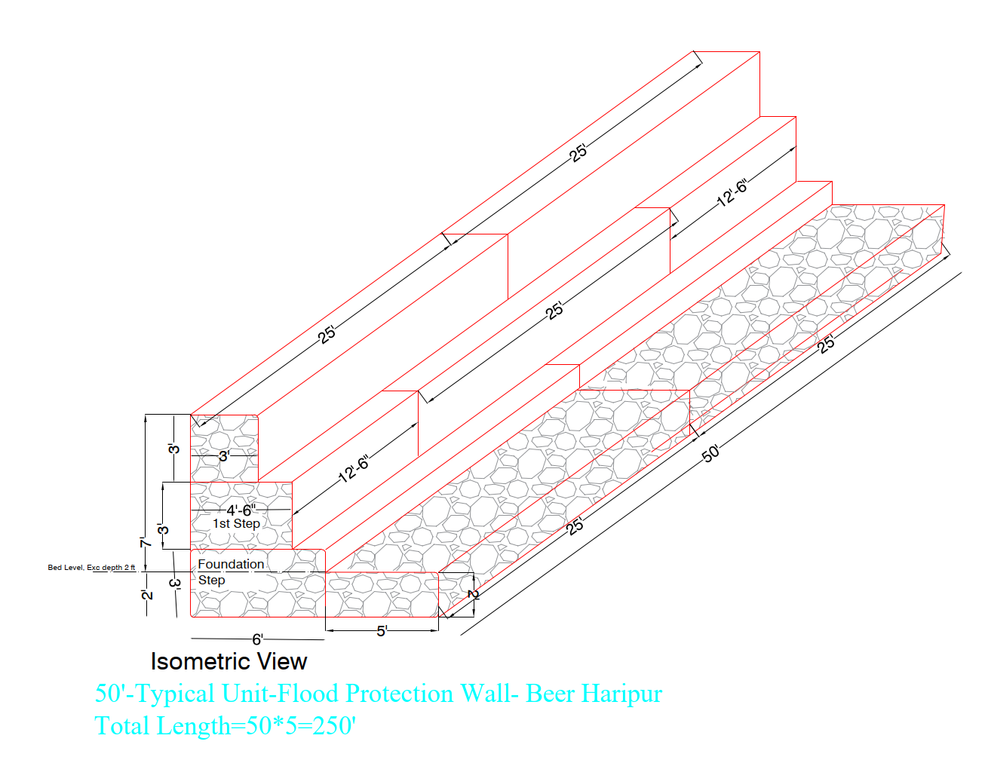

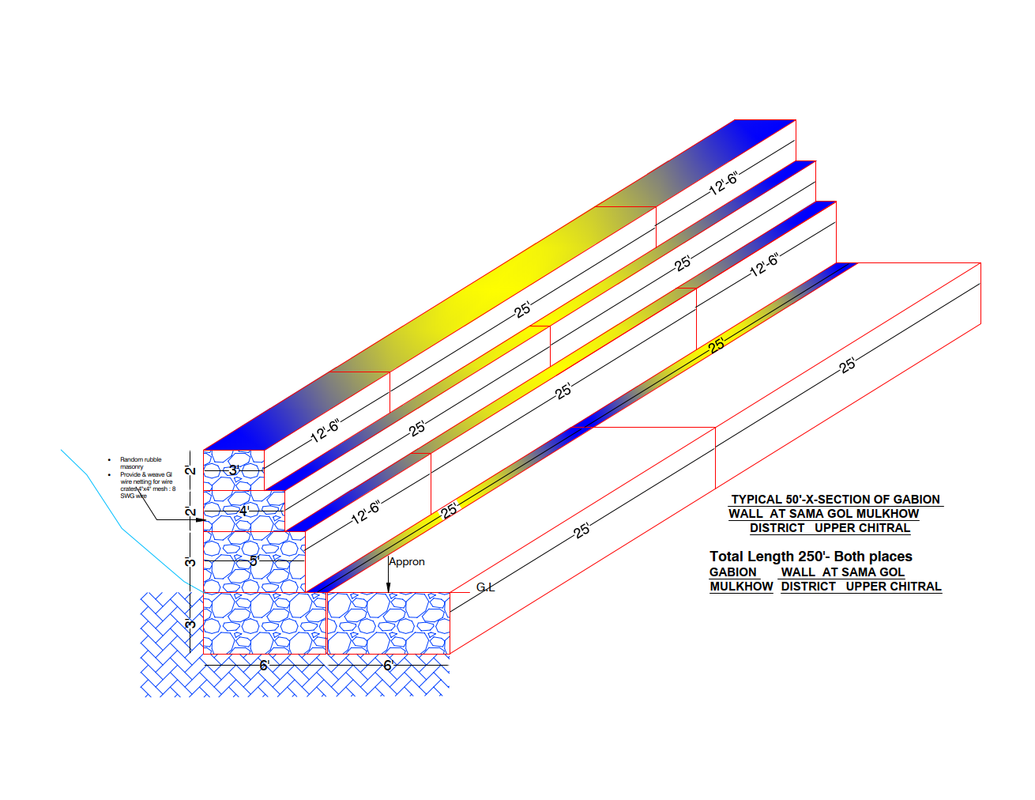

**Notes:**

1. **Delivery, Transportation at site shall be the responsibility of the supplier including loading, unloading, primary and secondary carriages etc.**
2. Bidder will be responsible for fault-free operations Purchaser Inspection committee will carry out the inspection of the items supplied. The decision of the inspecting authority regarding approval or rejection of the items will be final and binding to all concerned.
3. **Delivery/Implementation Timelines** for this project is Approx **1 Month** from the Signing of the agreement.

**Annex-B**

**Format of Financial Proposal**

1. Financial Proposal for required Goods/Services as per following details**:**

|  |  |  |  |  |  |
| --- | --- | --- | --- | --- | --- |
| **Sr. #** | **ITEMS** | **Unit** | **QUANTITIES** | **Unit Rate without Taxes** | **Total without Taxes** |
| (i) |  | **Nos** | **___** |  |  |
| **(ii)** |  | **Nos** |  |  |  |
| **Sub Total Without Taxes** | | | | |  |
| **GST %** | | | | |  |
| **Grand Total Inclusive of All taxes (DDP Basis)** | | | | |  |

**Payment Terms:**

Following Payment, the terms shall be followed:

|  |  |
| --- | --- |
| Advance Payment Upon Signing of Contract and provision of bank guarantee of at least 5% of the total value of the bid | 25 % |
| Upon Delivery of the GI Wire to all locations | 65 % |
| Remaining 10% payment upon receiving satisfactory lab reports; if unsatisfactory, the supplier to replace the stock | 10% |

1. The Contracts request(s) for payment shall be made to the WWF-Pakistan in writing, accompanied by an invoice, and delivery challans/Inspection Reports describing, as appropriate, the Equipment delivered upon the fulfillment of other obligations stipulated in the Contract.
2. Advance payment to be released against submission of at least 5% bank guarantee.
3. The currency of payment is Pak. Rupees.
4. All Taxes shall be deducted as per the Laws of the Government of Pakistan
5. If any Exemption on Taxes. Exemption Letter shall be provided along with the Financial Proposal.