# REQUEST FOR PROPOSAL FOR

**CONSTRUCTION/ INSTALLATION OF SOLAR POWERED WATER LIFTING PUMP AT DASS JAPUKAY, DISTRICT GHIZER, GILGIT BALTISTAN.**

1. **Introduction:**

WWF-Pakistan under National Competitive Bidding (“NCB”) has a requirement for the services of one qualified contractor to provide services for the supply, installation, configuration, integration, testing and commissioning of Solar Powered Water Lifting Pump for Irrigation Purpose in Village Japukay, District Ghizer, Gilgit-Baltistan.

1. **Submission of Bids:**

Bidder shall submit the Technical and Financial Proposal in Single Sealed Envelope Having Clearly mentioned following:

* Title of Procurement Construction of Solar Powered Water Lifting Pump
* Purchaser Address as mention in 2.3
  1. Only one rate should be quoted for the items and a bidder must avoid giving any alternate quote.
  2. Quotation must be typed or written in indelible ink and should be signed by an authorized representative. Without a signature on Form of Quotation, the quotation shall not be considered further. All pages of the submitted quotation(s) where entries or amendments have been made, should be signed or initialed by the person signing the quotation.
  3. A bidder shall submit Price Quotation, on their letterhead, duly signed, stamped by hand on Sealed envelope. The quotation should be addressed and delivered to the following official named official at the address mentioned underneath:

|  |  |  |
| --- | --- | --- |
| Purchaser’s Address | : | **Name: Younas Awan**  **Designation: Manager Administration**    WWF-Pakistan office, inside Ali Institute of Education, Ferozepur Road, Lahore |
| Telephone | : | 0423-5465983 |
| Email | : | [wwfadmin@wwf.org.pk](mailto:wwfadmin@wwf.org.pk) |

**For any queries, please write to** [**saashah@wwf.org.pk**](mailto:saashah@wwf.org.pk) **and** [**kshehzad@wwf.org.pk**](mailto:kshehzad@wwf.org.pk)

2.4. The quotation (s) should reach to authorize official, at the address indicated hereinabove, by or before **17th day of September 2025**

1. **Requirements:**

The Bidder should have a proper business address and office/shop besides complying with the following eligibility requirements through documentary evidence, to be submitted along with their Quotation:

1. The firm/company must be registered with Pakistan Engineering Council with active registration for the year 2025-2026 (Category C-5 and above with relevant Electrical codes EE-02, EE-03, EE-04, EE-06 & EE-11)
2. Registration with Income Tax Department. (If Applicable)
3. Registration with Sales Tax Department. (If applicable)
4. Proof of Active Tax Payer of Income & Sales Taxes. (If Applicable)
5. Similar projects implemented in GB, such as feasibility survey, design, estimation and implementation of Solar Powered Systems.
6. Experience in working with international Organizations.
7. Proven experience in developing community-based O&M modalities for water Lifting Pump.
8. Copies of filled application form along with submitted bank challan In case of renewal of PEC Registration
9. Local Contractors having valid licensed will be highly preferred.
10. Proven experience of working with community participation approaches in similar projects.
11. Bidders should provide valid Bank Account details which should not be different to the firm registered name.
12. The company or firm should be competent in providing technical services for maintenance of the same projects in consultation with local communities to ensure sustainability of the projects.
13. The bidder should provide data sheet of solar panels along with the bidding documents.

A bidder shall be selected as per the lowest evaluated responsive quotation(s) provided such bidder meets the qualification/eligibility requirements, referred to above.

1. **Additional Documentations:**

Following additional documents are required and would be used for **Financial Evaluation**:

1. Signed/Stamped copy of this RFP
2. Technical proposal of as per Technical Specification/TORs at **Annex-A**
3. Financial proposal with unit rates and total cost of work (Cost must be exclusive of all taxes) as per **Annex-B**
4. Company Profile/Past Work experiences.
5. Details of Leaflets/Broachers (If Any)
6. **Validity of Bids:**

Bids shall remain valid for a period of at least **90 days** from the date of submission of the quotation, which may be extended based on mutual discussion. A bid valid for a shorter period may be Consider as nonresponsive automatically without giving any further notice.

1. **Purchaser Right:**

WWF-Pakistan reserves the right to accept or reject any bid, and to annul the bidding process and reject all bids at any time prior to contract award, without thereby incurring any liability to the affected Bidder or bidders. The Purchaser will inform the affected Bidder or bidders of the grounds for the Purchaser’s action, if so requested, but the Purchaser shall not be required to justify the grounds.

* 1. Any bidder, if found engaged in corrupt or fraudulent practices (including collusion/polling will be declared ineligible either indefinitely or for a stated period of time.
  2. WWF-Pakistan also reserves the right to increase, decrease, delete or modify quantity to be delivered before the issuance of “Purchase/Supply Order” to the “Lowest Evaluated Bidder.

Regards,

**Name: Khurram Shehzad**

**Designation: Coordinator Conservation & Adaptation**

**Annex A**

**Technical Specifications/Terms of Reference/**

Following are the detailed Technical Specification and TORs for Solar Powered Water Lifting Pump for one unit only.

|  |  |  |  |  |  |  |
| --- | --- | --- | --- | --- | --- | --- |
| **DETAIL OF SOLAR COMPONENT** | | | | | | |
| **Solar Powered Water Lifting Pump Dass Japukey** | | | | | | |
| **S No** | **Item** | **Description** | **Unit** | **Qty** | **Unit Rate** | **Total Amount Rs** |
| 1 | **Solar Panel 615W or Higher (Tier A)** | Supply, Installation, Testing, and Commissioning of Tier-1, N-Type PV Modules (Longi LR5-72HGD-615 or equivalent), A++ quality, with module efficiency of 22.8%. Includes all necessary accessories, mounting, and interconnections as per system design. Warranty: 12 years product warranty and 30 years linear performance warranty. Complete in all respects | No. | 80 |  |  |
| 2 | **Hybrid Solar Pumping Inverter 37 kW** | Supply, Installation, Testing, and Commissioning of Hybrid Solar Pumping Inverter (INVT or equivalent), 37 kW capacity. Specifications: Max. DC input voltage 800 Vdc, MPPT range 460–850 Vdc, rated output 380–400 Vac, 3-phase, frequency 0–50/60 Hz. Includes 1-year manufacturer warranty for parts. Complete in all respects. | kW | 1 |  |  |
| 3 | **Enclosure Box (Hot Dipped Galvanized)** | Supply, Installation, Testing and Commissioning of Hot dipped galvanized, waterproof Enclosure Box with copper Busbars, Cable Glands, Locking Mechanism for Inverter and Breakers | No. | 1 |  |  |
| **4** | **Cabling DC/ AC** | **Supply, Laying, Testing, and Commissioning of DC Cable 1x6 mm², Double Coated (Cu/XLPO/XLPO)** suitable for solar applications. Cables shall be of Pakistan Cables or Fast Cables (or equivalent). Complete in all respects. | Lumpsum | 1 |  |  |
| 5 | **Solar Panels Mounting customized Structure** | Supply and installation of customized fixed structure (GI or Aluminium) over RCC concrete base, including welding/fixing with base plates, aluminium clips, and anchor bolts. Structure height: 1 ft (front) and 2–3 ft (rear) as per tilt angle requirements. Complete in all respects. | Watts | 49200 |  |  |
| 6 | **Accessories & Protection** | Supply, Installation, Testing, and Commissioning of Protection and Termination Accessories (All Chint), including:  DC String Breakers (Chint 20A, 1000V) – one per string DC Breaker (Chint 100A, 1000V) AC Breaker for Pump (Chint MCCB 63A, 3-Pole) DC SPD (Chint, 2-Pole, 20kA) AC SPD (Chint, 4-Pole, 40kA) MC4 Connectors, Fuses, Thimbles, Shrouds PVC Slotted Ducts, PVC Wiring Ducts, and Flexible Pipes All items to be supplied and installed complete in all respects as per system design. | Job | 1 |  |  |
| 7 | **HDPE/PVC Pipe for Wiring DC and AC Side with Excavation** | 32mm to 50mm as required Excavation for DC and AC Wiring Complete | Lumpsum | 1 |  |  |
| 8 | **Earthing (Separate Wiring) for Solar Panels & Structure, SPD, AC Wiring** | Proper Earthing for AC,DC and lighting arrestor 20 ft deep having 25 mm Pure Copper Rod, Earth Chemical, 16 mm Copper Conductor with all respect | Job | 1 |  |  |
| 9 | **Foundation Pads for Solar Panel mounting Structures** | Construction of foundation for each structural leg (1.5 ft x 1.5 ft x 2.5 ft) in PCC (1:2:4), including excavation, formwork, steel cage with mesh reinforcement, and anchor bolt placement. | Pads | 40 |  |  |
| 10 | **Submersible Pump 40hp** | Supply & Installation, testing and commissioning the **Submersible Pump** for water filling system of 160 US. Gpm and 640 Feet head as per manufacturer recommendation including all accessories like gate valves, non-return valves, pressure gauges, motor control panel (IP65) with dry run protection, indication light, phase reversal, automatic electrical level controller switch with complete wiring and 4C 16mm2 power cable AC 600/1000V, complete in all respect including all accessories. | No. | 1 |  |  |
| 11 | **60' Deep Boring** | Boring of 60' deep sump pit as per site conditions | RFT | 60 |  |  |

**Designs: Solar Powered Water Lifting Pump**

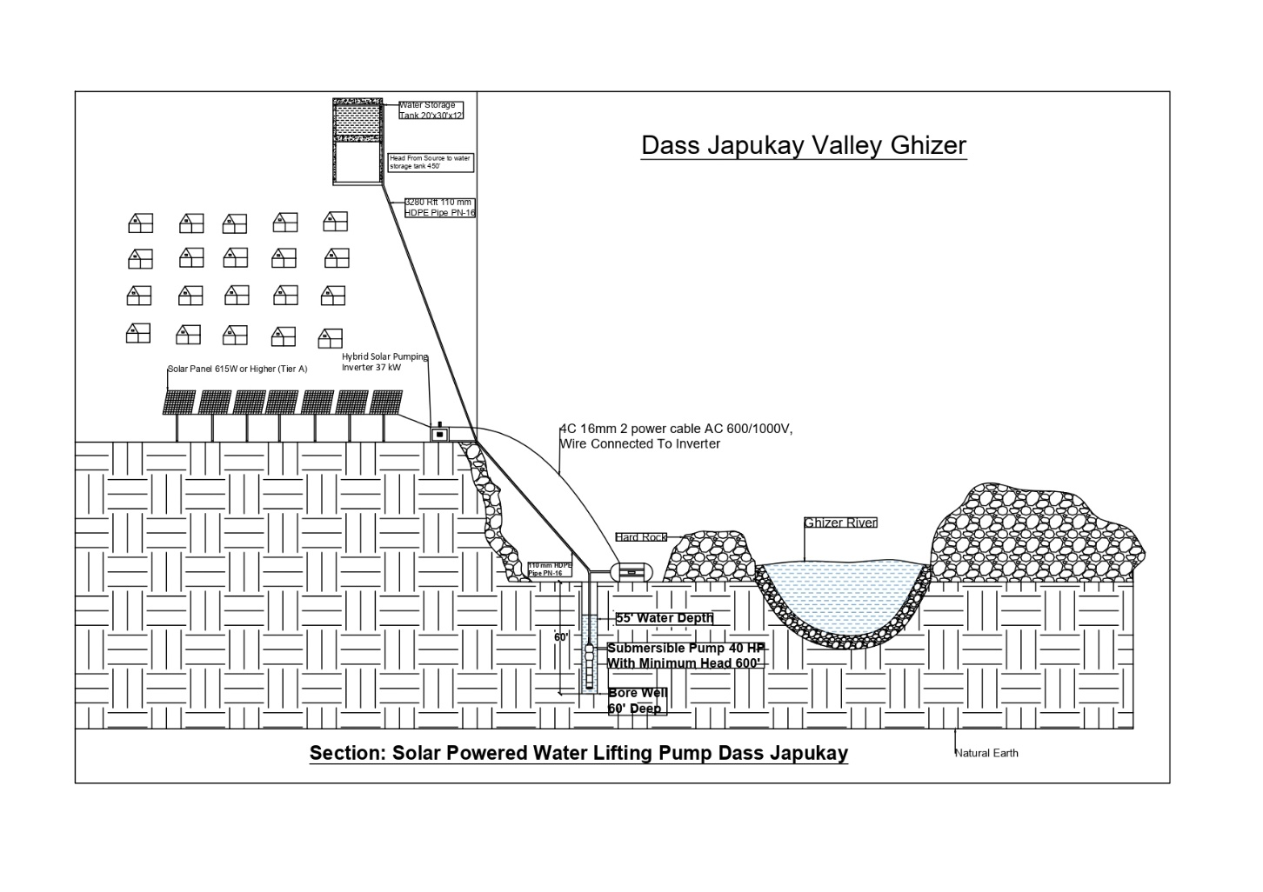

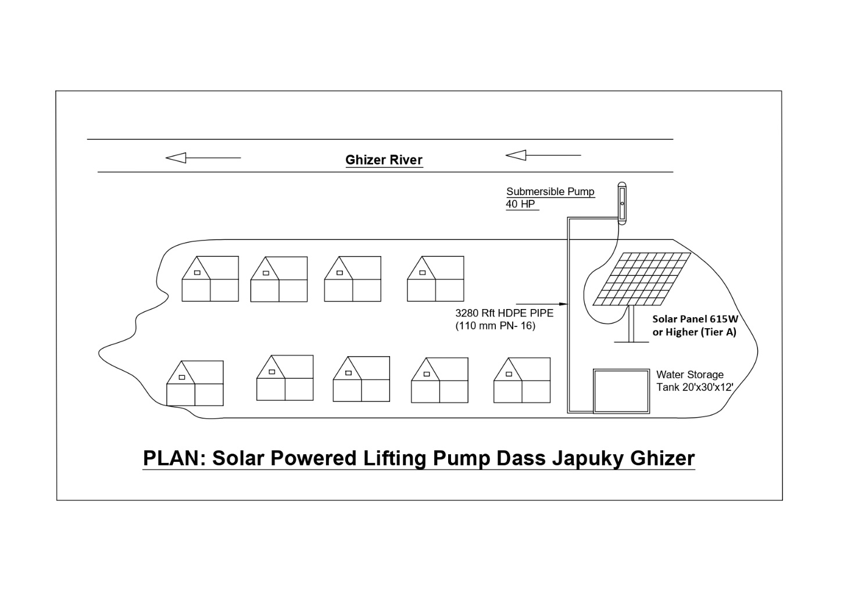

1. **Notes:**
   * 1. Delivery, Transportation and Installation at selected site shall be responsibility of the Supplier.
     2. The firms/vendor will ensure that the materials being supplied is brand new not Refurbished/ 2nd hand or used one.
     3. Bidder will be responsible for fault free operations. Purchaser Inspection committee will carry out the inspection of the items supplied. The decision of inspecting authority regarding approval or rejection of the items will be final and binding to all concerned.
     4. Services for Operation and maintenance cost for 6 months, follow-up visits, on job training for skill transfer for operation, repair and maintenance technique.
     5. Proposed site:

Das Japukay, Ghizer GB

N 36°6'11"

E 73°55' 16"

Elevation 5860 feet

1. **Payment Terms:**

Following Payment, the terms shall be followed:

|  |  |
| --- | --- |
| Advance Payment Upon Signing of Contract | 30 % |
| Upon completion of Civil Work (Construction of Sump) | 30% |
| Upon completion/Installation of 40 HP Solar Pump and installation of PV Panels | 35% |
| Retention Money@ 5% on completion of O&M period of 6 months * | 5% |

* 1. The Contracts request(s) for payment shall be made to the WWF-Pakistan in writing, accompanied by an invoice, and delivery challans/Inspection Reports describing, as appropriate, the materials delivered upon the fulfillment of other obligations stipulated in the Contract.
  2. The currency of payment is Pak. Rupees.
  3. All Taxes shall be Deducted as per the Laws of Government of Pakistan
  4. If any Exemption on Taxes Exemption Letter shall be provided along with the Financial Proposal.

**Annex-B**

**Format of Financial Proposal**

1. Financial Proposal for required Goods/Services as per following details**:**

|  |  |  |  |  |
| --- | --- | --- | --- | --- |
| **Sr. #** | **ITEMS** | **Unit** | **QUANTITIES** | **Total Without Taxes** |
|  |  |  |  |  |
|  |  |  |  |  |
|  |  |  |  |  |
|  |  |  |  |  |
|  | | | |  |
| **GST %** | | | |  |
| **Grand Total Inclusive of All taxes (DDP Basis)** | | | |  |
| **Retention money 10% of Grand Total inclusive of all taxes** | | | |  |