**REQUEST FOR PROPOSAL**

**FOR**

**CONSTRUCTION OF 04 UNITS OF ABLUTION WATER REUSE SYSTEMS IN MULTAN REGION**

# **Introduction:**

WWF-Pakistan under National Competitive Bidding (“NCB”) has a requirement for the services of one qualified bidder to provide services for the construction of 04 units of ablution water reuse systems (AWRS) in Multan region for minimizing the groundwater extraction and reuse it for different purposes including (but not limited to) agriculture/horticulture, floor/car washing.

# **Submission of Bids:**

The Bidder shall submit the technical and financial proposal via sealed envelope and clearly mentioned followings:

* Title of procurement for the construction of 04 units of ablution water reuse systems in Multan region. Sites name/location are available in financial proposal.
* Purchaser name and address as mentioned in 2.3.

2.1 Only one rate should be quoted for the item, and a bidder must avoid giving any alternate quote.

2.2 Bid must be typed or written in indelible ink and should be signed by an authorized representative. Without a signature on form of bid, the bid shall not be considered further. All pages of the submitted bid(s) where entries or amendments have been made, should be signed or initiated by the person signing the bid.

2.3 A bidder shall submit price bid on their letterhead, duly signed, stamped by hand on sealed envelope. The bid should be addressed and delivered to the following official named official at the address mentioned below:

|  |  |  |
| --- | --- | --- |
| Purchaser’s Address | : | **Name: Muhammad Younas Awan**  **Designation:** Manager Administration  World Wide Fund (WWF) for Nature,  Inside the Ali Institute of Education, Ferozepur Road Lahore (Pakistan)  P.O Box 5180 |
| Email | : | **wwfadmin@wwf.org.pk** |

**For any queries, please write to** [**miazam@wwf.org.pk**](mailto:miazam@wwf.org.pk), [**hznawaz@wwwf.org.pk**](mailto:hznawaz@wwwf.org.pk), [**mzqasim@wwf.org.pk**](mailto:mzqasim@wwf.org.pk), and [**maleem@wwf.org.pk**](mailto:maleem@wwf.org.pk).

2.4. The bid (s) should reach to authorize official, at the address indicated hereinabove, in a sealed envelope before **08 October 2025**.

# **Requirements:**

The bidder should have a proper business address and office/shop besides complying with the following eligibility requirements through documentary evidence, to be submitted along with their bid:

1. Registration with Income Tax Department.
2. Registration with Sales Tax Department.
3. Proof of Active Tax Payer of Income & Sales Taxes.
4. Minimum 03 years of experience in constructions services
5. PEC Registration (minimum C6)

A bidder will be selected as per the lowest evaluated responsive bid(s) provided such bidder meets the qualification/eligibility requirements, referred to above.

# **Additional Documentations:**

Following additional documents are required and would be used for **Technical/ Financial Evaluation**:

1. Signed/stamped copy of this RFP
2. Technical proposal of as per technical specification/TORs at **Annex-A**
3. Financial proposal with unit rates and total cost of work (Cost must be exclusive of all taxes) as per **Annex-B**
4. Company profile
5. Details of brand/leaflets/broachers (If any)

# **Validity of Bids:**

Bids shall remain valid for a period of at least **20 days** from the date of submission of the bid, which may be extended based on mutual discussion.

A bid valid for a shorter period may be considered nonresponsive.

# **Purchaser Right:**

WWF-Pakistan reserves the right to accept or reject any bid, and to annul the bid process and reject all bids at any time prior to contract award, without thereby incurring any liability to the affected bidder or bidders. The purchaser will inform the affected bidder or bidders of the grounds for the purchaser’s action, if so requested, but the purchaser shall not be required to justify the grounds.

6.1 Any bidder, if found engaged in corrupt or fraudulent practices (including collusion/polling will be declared ineligible either indefinitely or for a stated period of time.

6.2 WWF-Pakistan also reserves the right to increase, decrease, delete or modify quantity to be delivered before the issuance of “Purchase/Supply Order” to the “Lowest Evaluated bidder.

Regards,

**Kashifa Saleem**

**Coordinator | Freshwater**

# **Annexure A-1:** Drawing of 3m3 of AWRS in Multan Region

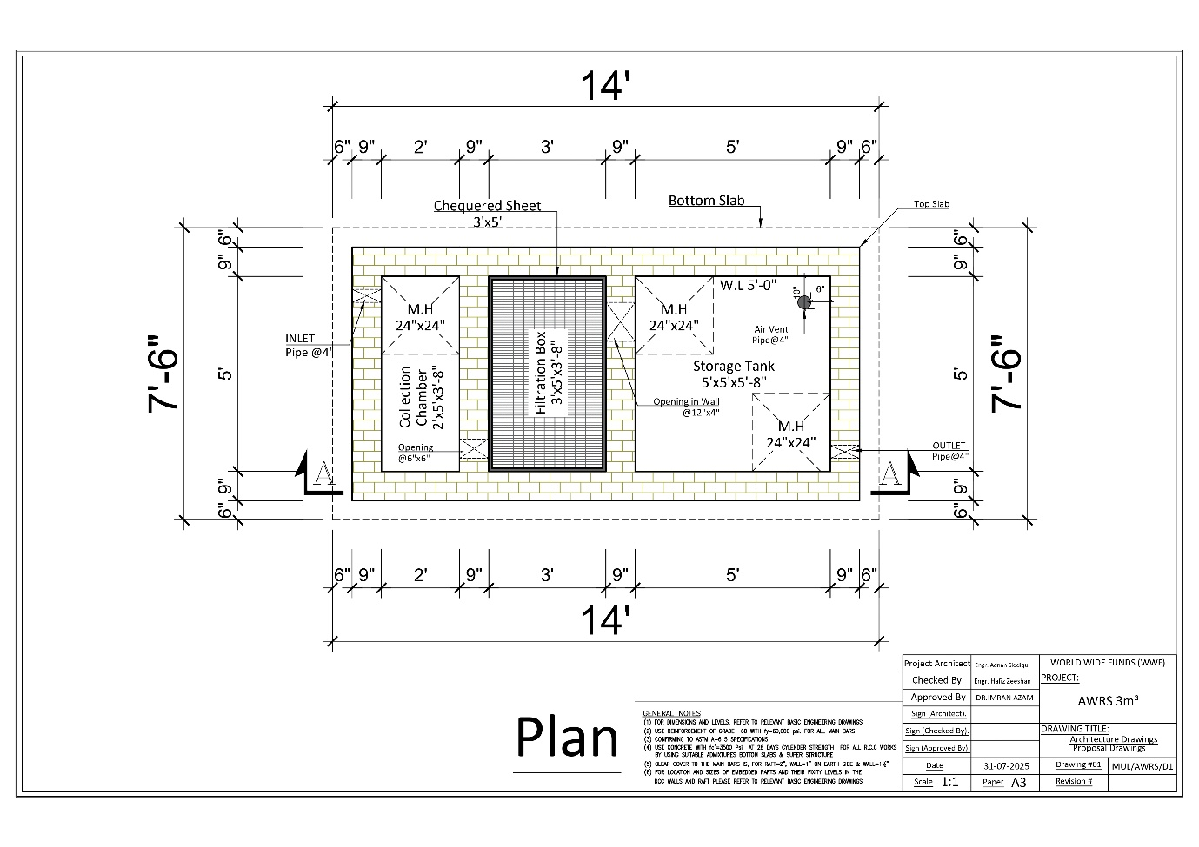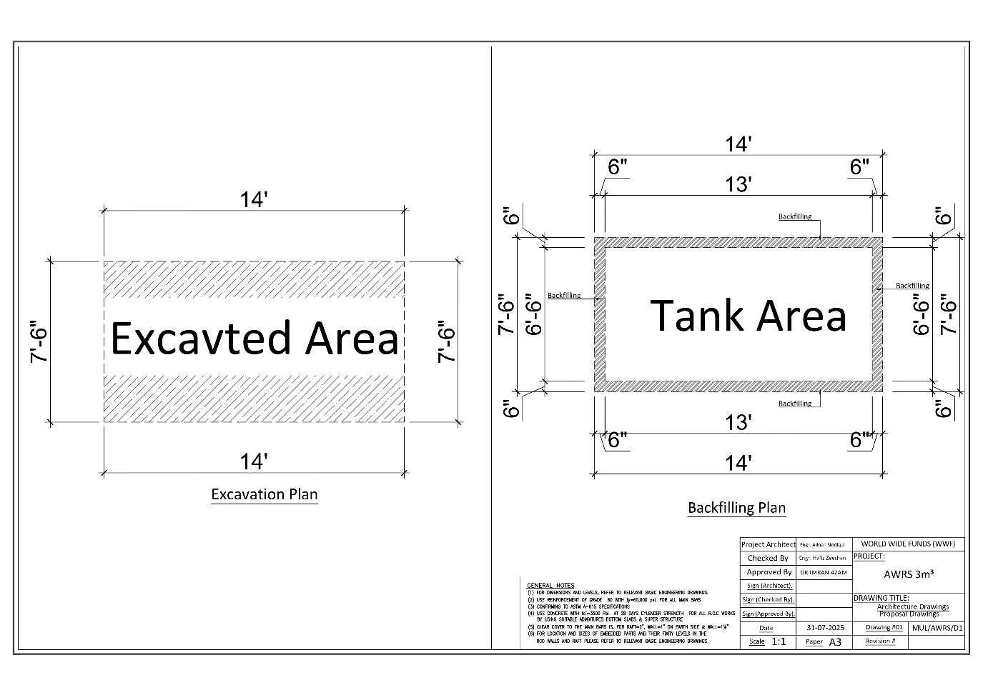

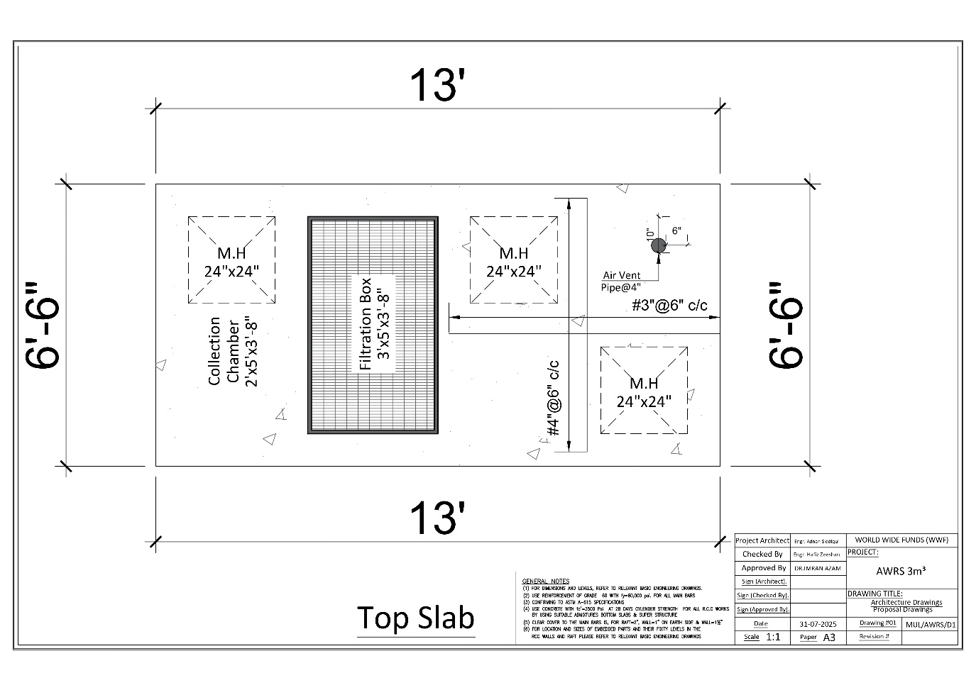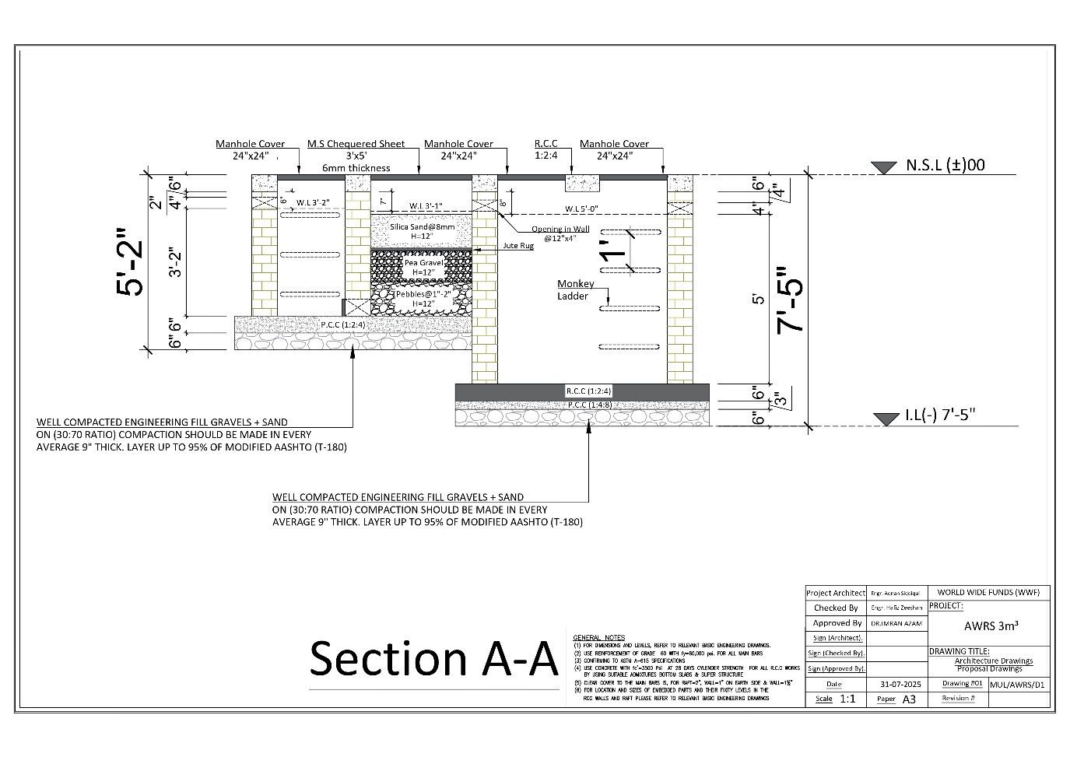

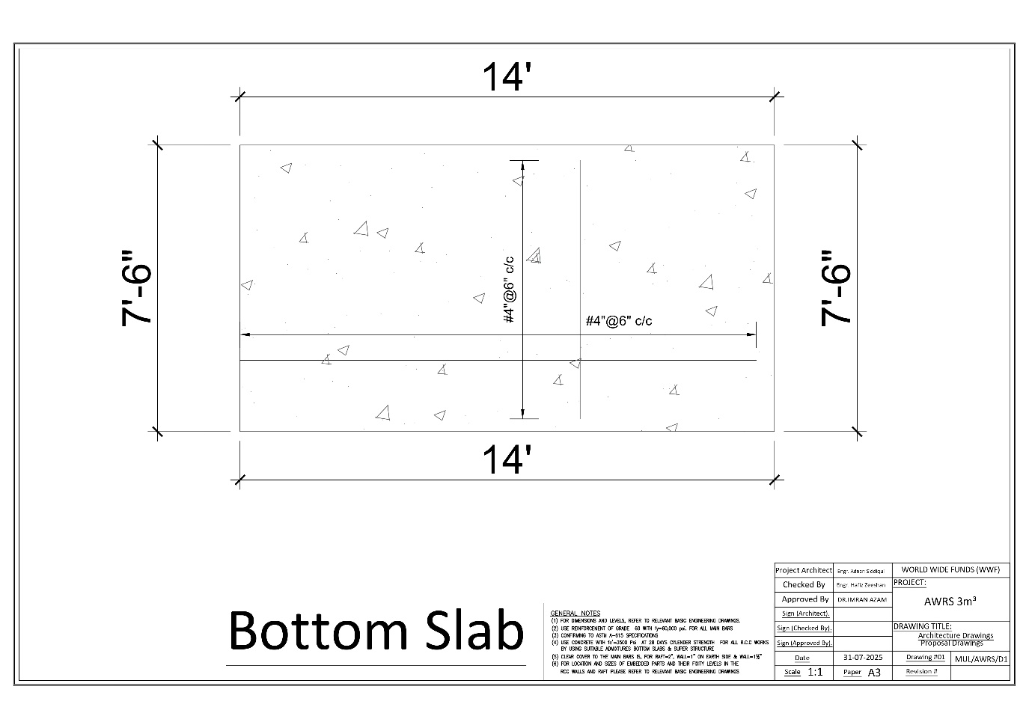

# **Annexure A-2:** Drawing of 7m3 of AWRS in Multan Region

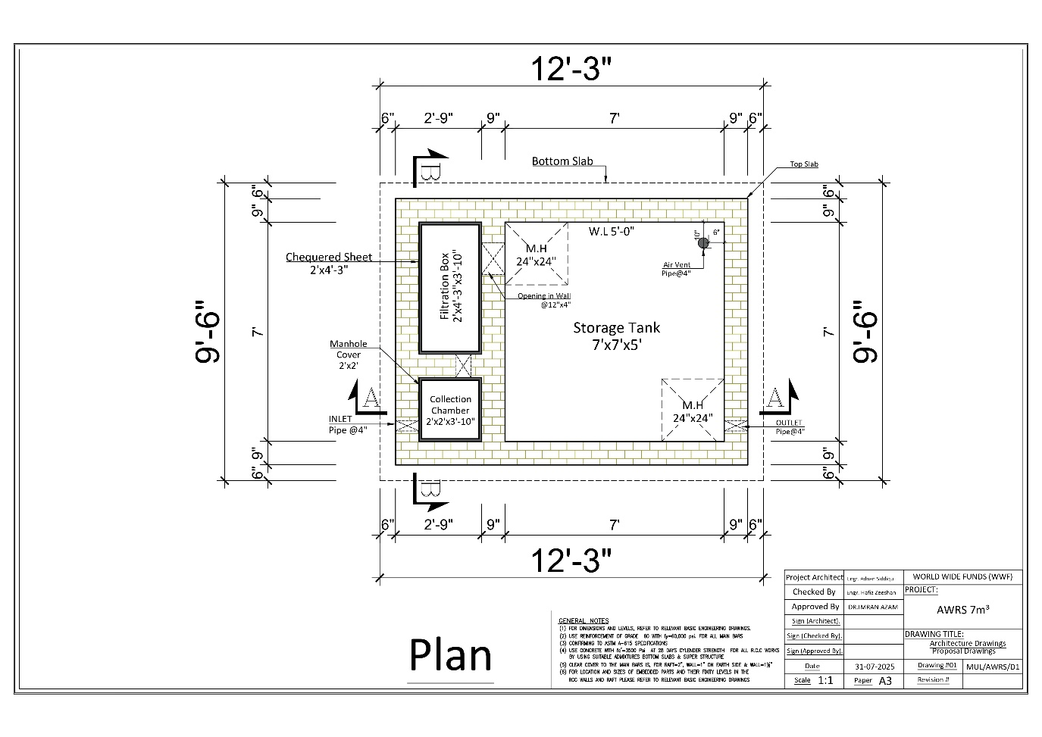

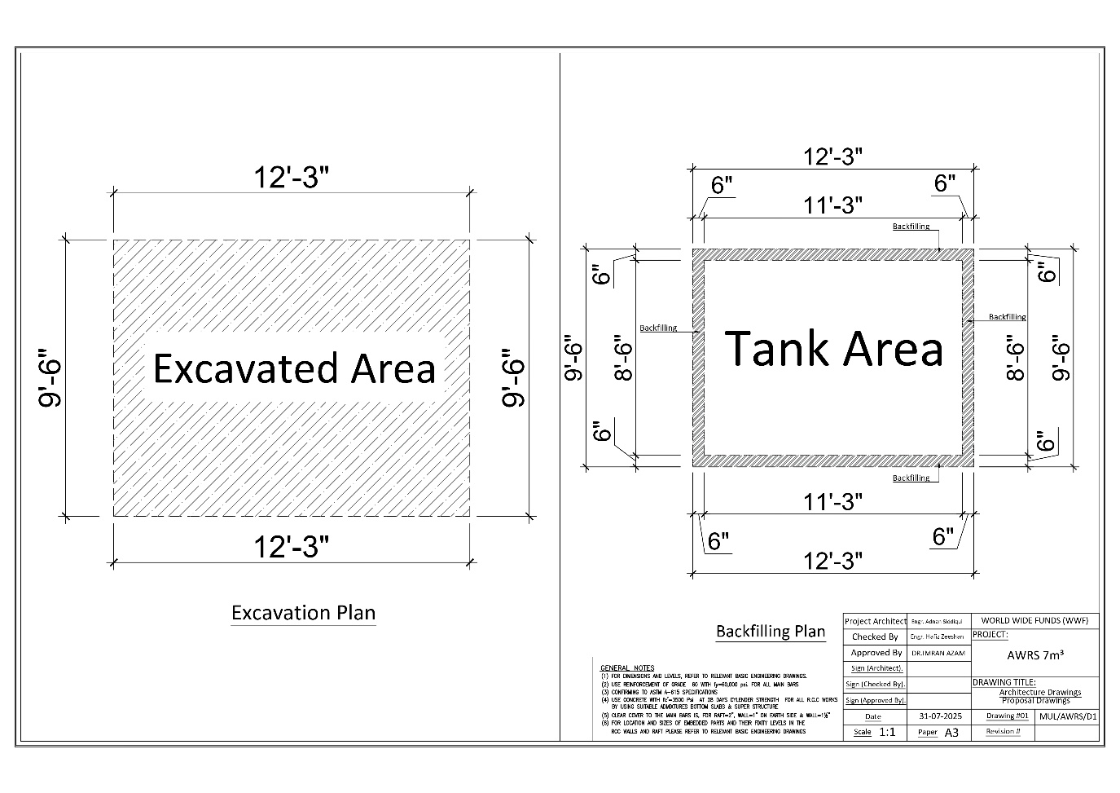

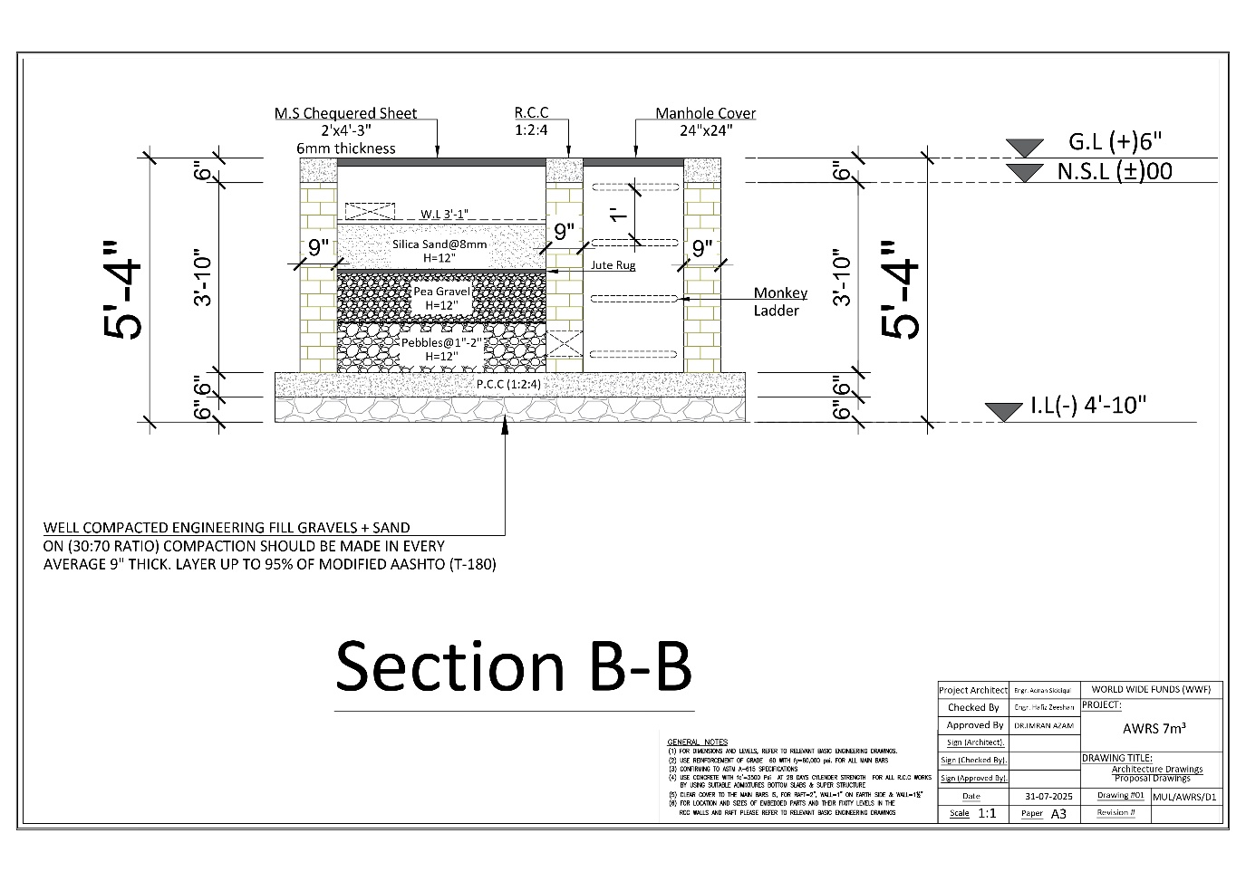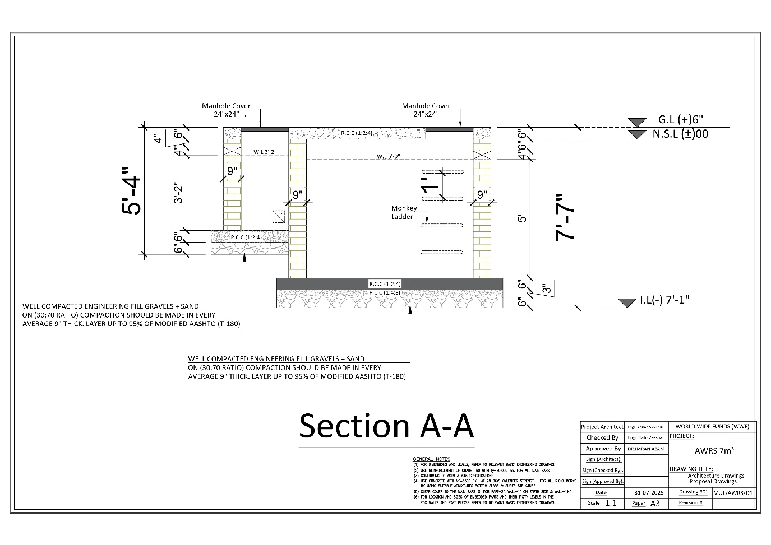

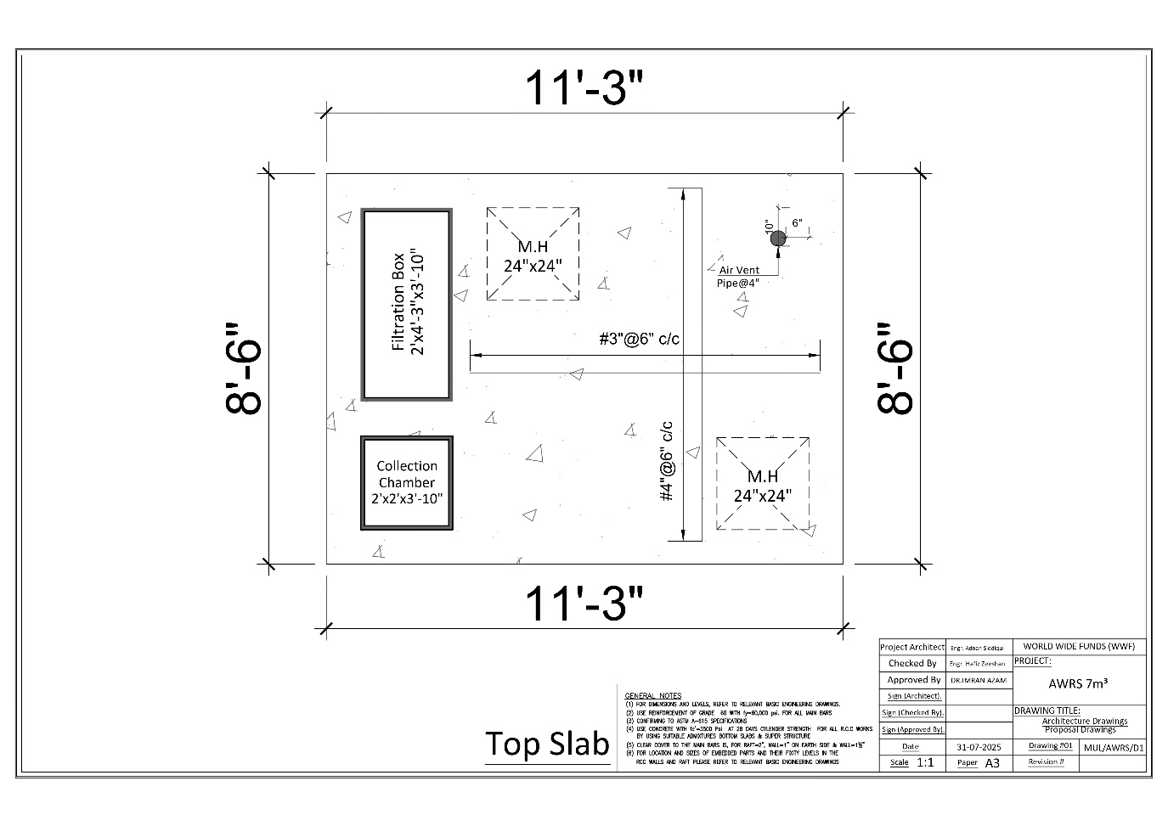

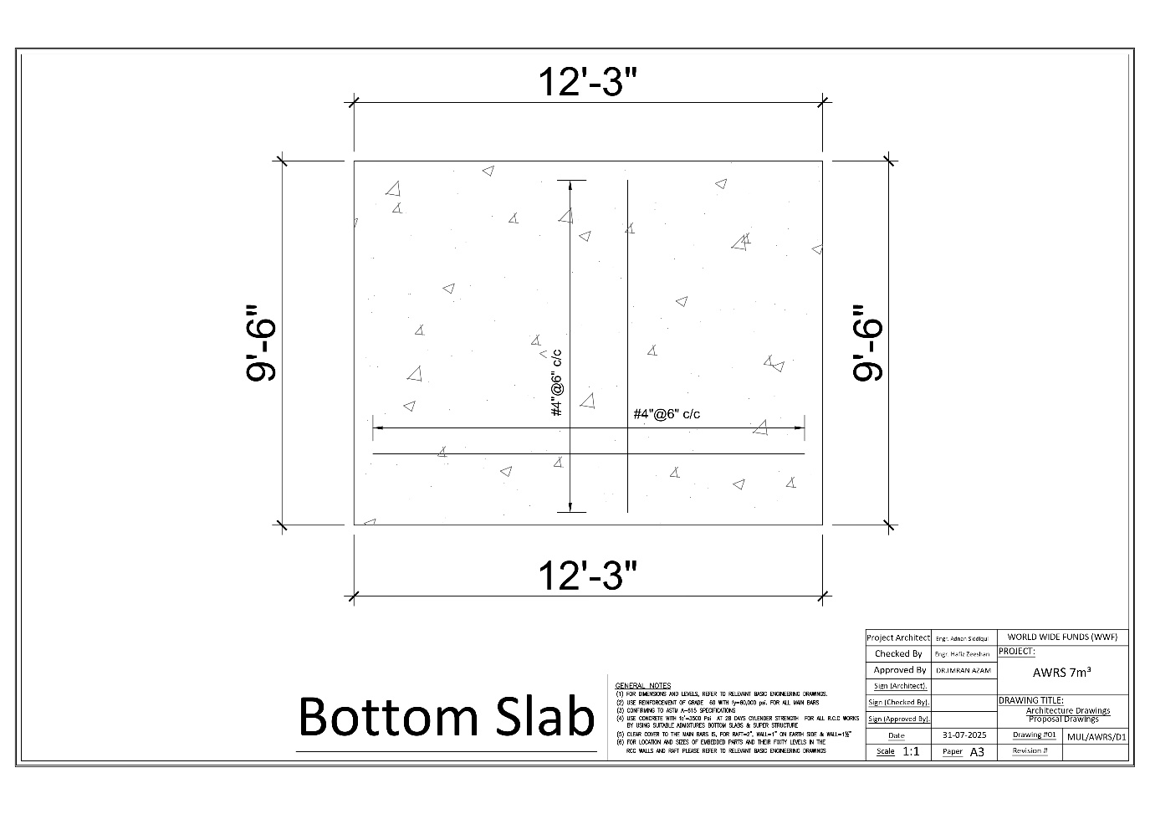

# **Annexure B-1:** Bill of Quantities (BOQs) for two units of 3 m3 AWRS in Multan







# **Annexure B-2:** Bill of Quantities (BOQs) for two units of 7 m3 AWRS in Multan







# **Format of Financial Proposal**

Financial Proposal for required Goods/Services as per following details**:**

**Payment Terms:**

Following payment, the terms shall be followed:

|  |  |
| --- | --- |
| **Payment Conditions** | **Payment Terms** |
| Advance After Signing of Agreement | 25% |
| After 100% Completion of 07 m3 of One AWRS Unit at Jamia Mosque, Al Quresh Housing Society, Near Muzaffarabad, Multan | 20% after successful inspection report |
| After 100% Completion of 07 m3 of Second AWRS Unit at Jamia Mosque, Wapda Town, Phase-I, E-Block, Multan | 30% after successful inspection report |
| After 100% Completion of 03 m3 of Two Units of AWRS at Jamia Mosque Faridiya, Adjacent to PHA Park, Muzaffarabad, Multan and Jamiul Aloom Madarassa, Multan Industrial Estates | 20% after successful inspection reports |
| Payment After Six Month’s Defect and Liability Period | 5% |

1. The contracts request(s) for payment shall be made to the WWF-Pakistan in writing, accompanied by an invoice, and delivery challans/inspection reports describing, as appropriate, the equipment delivered upon the fulfillment of other obligations stipulated in the contract (if and when is applicable).
2. The currency of payment is in Pakistani Rupees.
3. All taxes shall be deducted as per the Laws of the Government of Pakistan.
4. If there is any exemption on taxes, exemption letter shall be provided along with the financial proposal.