Stung Treng Zero-Snaring Campaign
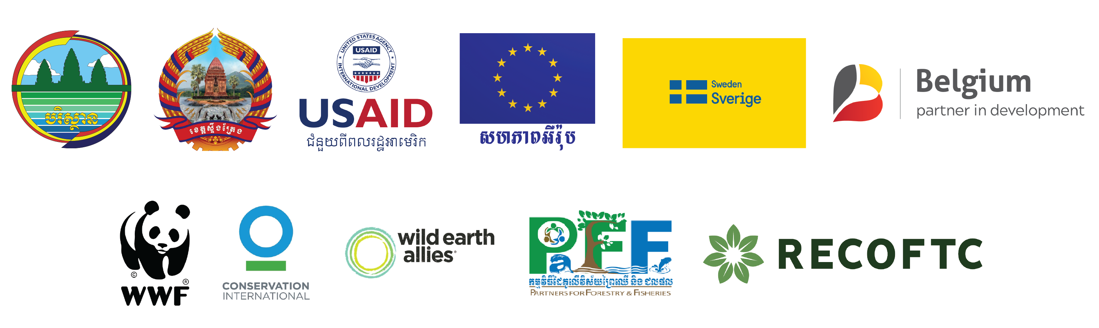

Joint Media Release:
Local people participation is critical to ending snaring crisis and illegal wildlife trade in Cambodia

Stung Treng, 7 April 2022 – The Zero-Snaring in Cambodia’s Protected Areas campaign actively seeks the participation from local communities to eradicate all types of snaring in Cambodia’s forests as it now travels to Stung Treng province.

“From a local villager to local transporter, to city market food vendor to restaurant owner in town and consumer, the community participation plays an important role in making the forests safe for wildlife survival and in stopping poachers from setting-up snares in forest habitats,” said His Excellency Neth Pheaktra, Secretary of State to Ministry of Environment.

The Ministry of Environment calls on all people to stop consuming wild meat and all other wildlife products. “We urge all people across Cambodia to say no to wild meat and participate in conserving the Kingdom’s natural resources,” His Excellency Neth Pheaktra added.

Buddhist monks demonstrated their crucial role in integrating in their dharma sermons the need for wildlife protection and amplifying demand reduction messages that will strongly influence attitudes and behaviors, and ultimately, social norms.

“Everyone has a role to play in protecting and restoring wildlife and natural resources, including Buddhist monks. We recognize our role in influencing people’s attitudes and beliefs about consuming bush meat and wildlife products,” said Venerable Tho Thoross, Preah Vinay Thor Provincial Council and Chief Priest of Rukhavorn Community.

“It is important that we integrate conservation and wildlife demand reduction messaging in our regular conversations with Buddhist followers,” he added.

From its official launch in Phnom Penh in early March to its begging rally in the province, the campaign calls for immediate actions to strengthen law enforcement and legislation to end poaching and snaring crisis that are increasingly threatening Cambodia’s wildlife.

“Strictly implementing law enforcement and bringing snare setters, hunters and wildlife traders to court, are essential to end the killings,” said Mr. Seng Teak, WWF-Cambodia Country Director. “Furthermore, all local bushmeat markets must be closed down and regularly monitored by the mobile law enforcement officers,” Mr. Teak added.

It is not too late to make a difference, but only if we start now at every level to take immediate collective conservation actions for conserving forests and reversing nature loss. If immediate steps are not taken, Cambodia risks losing its globally irreplaceable wildlife in the future.

“This campaign will help increase the public’s understanding of the dangers Cambodia’s wildlife face every day. To address these dangers, adequate resources much be provided to the wildlife protection agencies, who can adopt innovative solutions to address the root causes of the wildlife trade, and put nature on the path to recovery,” said Dr. Jackson Frechette, Greater Mekong Landscape Director of CI.

Through more involvement in the community-based natural resource management local people can play their part to better develop their livelihoods while participating in the protection of globally important wildlife species, reversing nature loss in Cambodia.

“In this campaign, we call for more active involvement with local communities in the management, use, and sharing of natural resources to support sustainable development and to create space where humans and nature can live in harmony,” said Mr. Tuy Sereivathana, Programme Director of Wild Earth Allies Cambodia.

“The continued engagement of local communities in sustainable natural resources management is essential to ensure that they benefit from long-term investment and business opportunities by improving market links for income generation as well as contributing to end wildlife’s poaching and snaring crisis,” said Ms. Hou Kalyan, Cambodia Country Director, RECOFTC.

On 3rd of March 2022, a coalition of government ministries and international conservation organizations together launched the Zero-Snaring in Cambodia’s Protected Areas campaign and collectively pledged to take actions toward ending the snaring crisis and illegal wildlife trade in Cambodia. The provincial rallies will last six months and take place in Stung Treng, Preah Vihea, Kratie, Mondulkiri, Kampong Thom and Ratanakiri provinces.

-Ends-

For more information, please contact:
His Excellency Neth Pheaktra, Secretary of State to the Ministry of Environment
Mobile: 012 483 283

Or reach out to
The campaign’s secretariat
TEP Asnarith
Mobile: 012 957 919

Link to other information and photos: https://bit.ly/3IHNGhW

