TERMS OF REFERENCE

CALL FOR APPLICATIONS - Environmental Impact Assessment (EIA)
for the Annamite Endangered Species Conservation Centre in Bach Ma National Park under the Rewilding the Annamites project (WWF-Viet Nam)

- Background
Rewilding the Annamites is a project awarded to WWF-Viet Nam by the Critical Ecosystem Partnership Fund (CEPF) for the period July 2021 – June 2023 aiming to address the defaunation crisis in the Central Annamites Landscape of Viet Nam by laying the foundations for a proof of concept on rewilding approaches for threatened Annamitic endemics occurring at low densities. Hence, the project goal is to create supporting conditions and systems for the demonstrable recovery of ungulates, rabbits, pheasants, and turtles within the Central Annamites of Viet Nam. The specific objectives of the project include:
- Objective 1: Identify two micro-watersheds suitable for the re-introduction (population restoration through reinforcement) of ungulates, rabbits, pheasants, and turtles.
- Objective 2: Catalyse the recovery of ungulates, rabbits, pheasants, and turtles under human care to supply rewilding efforts.
- Objective 3: Deliver a baseline for ungulate, rabbit, pheasant, and turtle recovery efforts in two micro-watersheds
Objective 2 described above includes the construction of a Annamite Endangered Species Conservation Centre, a conservation breeding facilities in Bach Ma National Park for threatened Annamite endemic species under a partnership between Bach Ma National Park (BMNP), WWF-Viet Nam, Re:Wild, Asian Turtle Program (ATP), and Wroclaw Zoo to secure conservation breeding populations to source future species re-introductions in the Central Annamites. The project will fund the construction of enclosures (and associated fencing and security measures) for ungulates (Large-antlered Muntjac), rabbits (Annamite Striped Rabbit), pheasants (Crested Argus) and tortoises (Bourret's Box Tortoise) (see section 2 below).
Constructions of the Bach Ma breeding centre are planned to start in January 2022. As required by the CEPF safeguard policy and Viet Nam’s regulations for project approval, an Environmental Impact Assessment (EIA) should be implemented and approved before construction activities can start.
The Consultant (here in after call the Client) will be recruited by WWF-Viet Nam to conduct an EIA for the above facilities under CEPF and WWF-Viet Nam budget.
- The Annamite Endangered Species Conservation Centre in Bach Ma National Park
Located in Central Viet Nam, Bach Ma National Park is part of the CEPF priority Central Annamites Corridor identified in the CEPF Indo-Burma Ecosystem profile and listed as a priority Key Biodiversity Area (KBA) under VNM7. The parks goal is to manage, protect, conserve and sustainable use all forest and forest land areas assigned for management under Bach Ma National Park, meeting economic, social and environmental requirements. Bach Ma National Park falls within the administrative boundaries of Thua Thien Hue and Quang Nam provinces in central Viet Nam. The buffer zone includes 15 communes and towns of three districts: Phu Loc and Nam Dong (Thua Thien Hue province) and Dong Giang (Quang Nam province).
Bach Ma National currently has a Centre for Rescue, Biological Conservation and Development within the service-administrative zone. The goal, as also included in the Sustainable Forest Management Plan (SFMP) for Bach Ma National Park, is to further expand the capacity and the function of Bach Ma National Park as a rescue and rehabilitation centre and to construct independent facilities to also allow for conservation ex-situ captive breeding for reintroductions purposes.
The conservation breeding centre has been designed by top zoo architects based on field visits in 2019 and has been peer reviewed by multiple zoo directors and animal husbandry experts. Funding has been secured for most of the core elements of the centre such as veterinary facilities, quarantine space, and administrative offices, which involves repurposing existing buildings rather than additional construction (see Figure 1).
The construction of additional animal enclosures will be supported via this CEPF grant under WWF-Viet Nam to provide taxon specific and appropriate habitats for ex-situ breeding (see Figure 2). The construction of these facilities will be conducted within the Service and Administrative subdivision of the park, which is designated for the construction of facilities to manage services of protected areas.
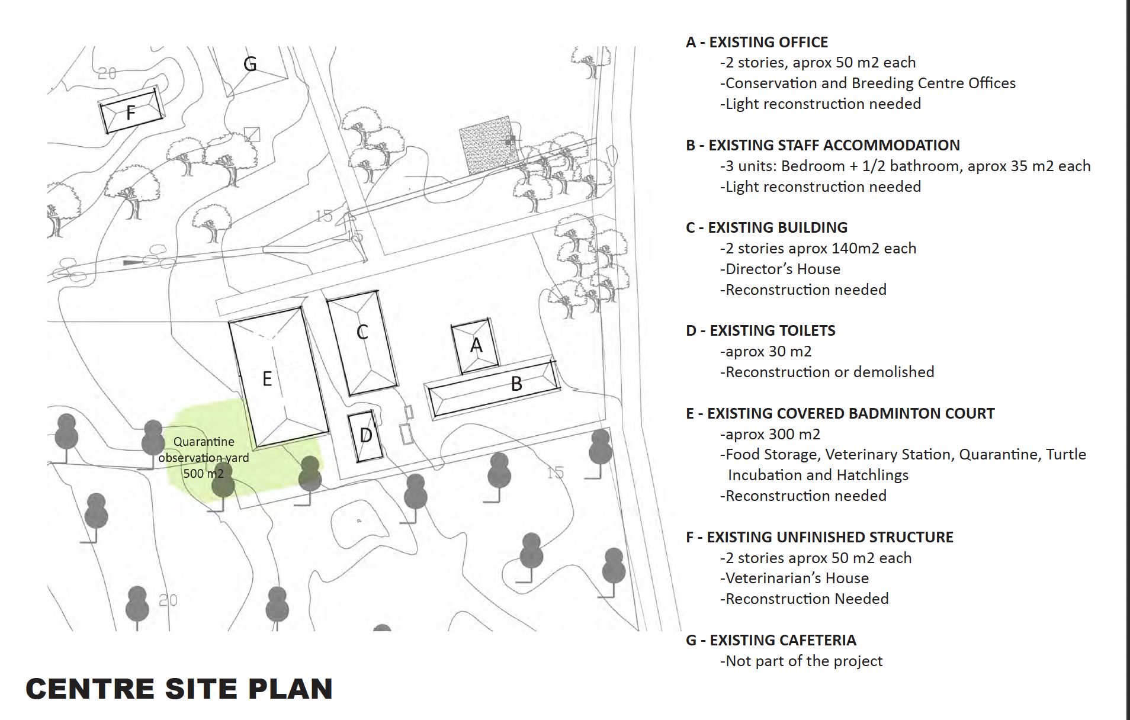
Figure 1. Plan for repurposing of existing infrastructure.

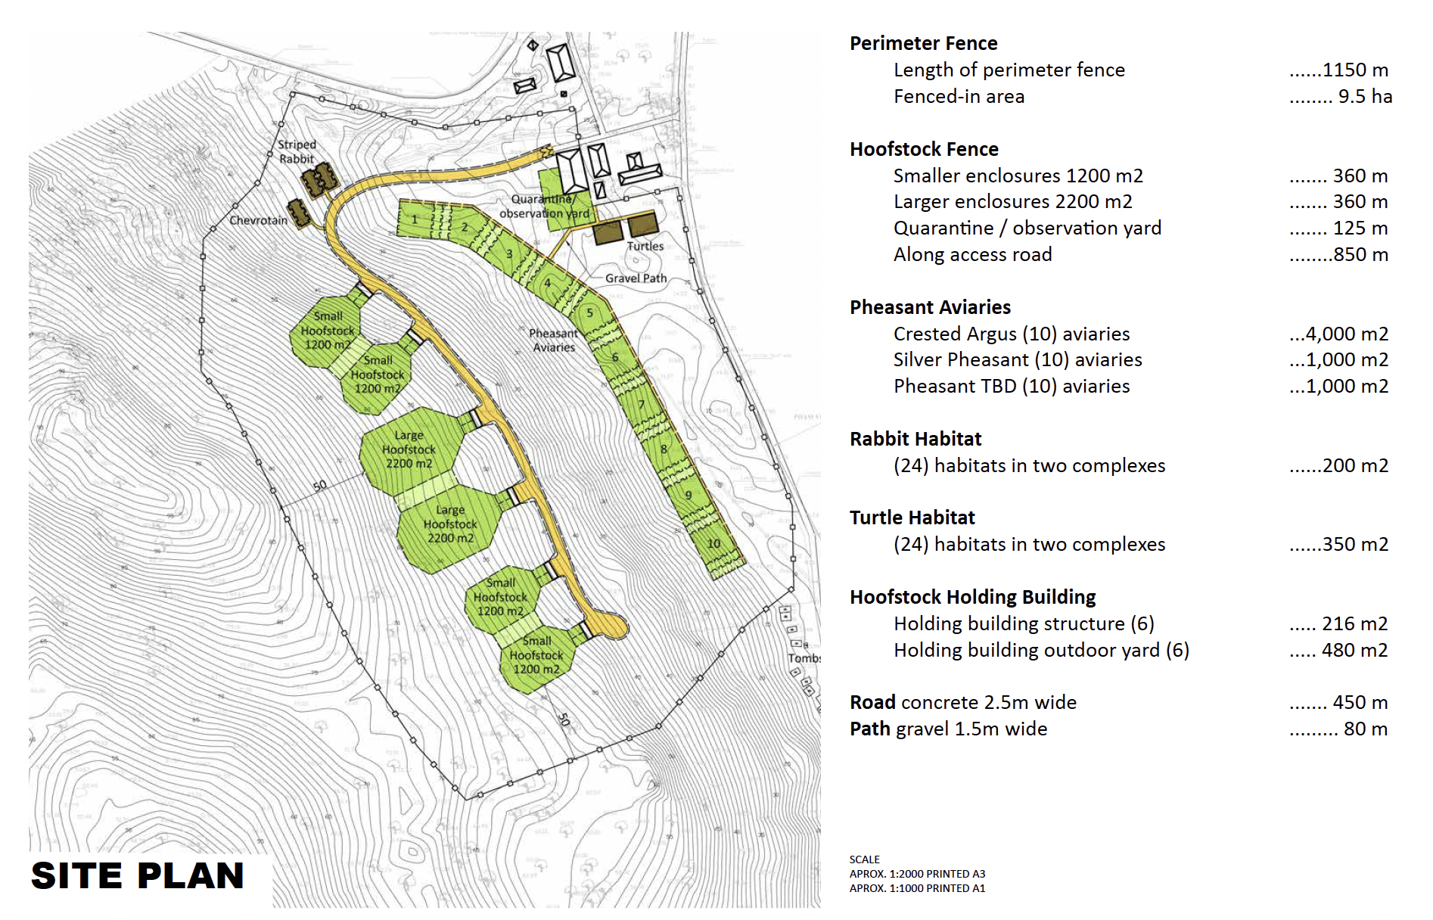
Figure 2. Plan for new enclosures for target species.

The facilities will include:
- Construction of three ungulate habitats of 1,200m2 each. Each 1,200m2 habitat will be constructed with 2m high fencing and be paired with a 16m2 holding enclosure. Enclosures will have connecting gates 1m wide.
- Construction of eight rabbit habitats of 50 m² each. Each habitat will be constructed with a concrete curb perimeter and dig barrier to prevent the rabbits from digging out and/or predators from digging in. The habitat will be completely enclosed with Aviary mesh panels to prevent escape and/or predators from entering the habitat. Each habitat will be interconnected with rabbit size doors to allow managers to place rabbits together without having to physically move them.
- Construction of eight pheasant aviaries, each 35 m² and 4.5 m high. Each aviary will be constructed with a concrete curb perimeter and dig barrier to prevent predators from entering the aviary. The aviary will be completely enclosed with Aviary mesh panels to prevent escape and/or predators from entering the habitat. Each aviary will be interconnected with doors to allow managers to move the birds without any physical restraint.
- Construction of two secure cages for tortoises, each 150m² and subdivided into 12 breeding enclosures.
The road construction and perimeter fence shown in Figure 2 will be conducted under Bach Ma NP funding.
- Applicable safeguard standards and requirement
Safeguard policies and standards required by the (i) CEPF Environmental and Social Management Framework can be found here, and WWF’s Environmental and Social Safeguards Framework (ESSF) here. The current requirements of GoV on EIA and construction are applied for this Assignment.

- Scope of the assignment
- Review project report and safeguard policies and standards
The Client is required to review: (i) all current safeguard policies and standards that currently apply to CEPF, WWF and the GoV; and (ii) all relevant project documents which may include feasibility study, preliminary design, and so on as required and provided by the contractor.
- Determine scope of EIA, survey and collection of baseline data
The Client is required to determine the scope of the EIA before site surveys and baseline data collection. Baseline data should, at least, cover information as follow:
- Current state of physical environment and biological resources, climate and hydrology, air environment, surface water resources, groundwater quality, land resources and land use status, topographical features, characteristics of biological resources, sensitive works within the project area and surrounding areas.
- Socio-economic data including population, labour, education, ethnicity, religion, gender, status of economic development (agriculture, forestry, fisheries, industry and services), income and livelihood of local resident, current status of water use and water supply, and current status of community health and sanitation.
- Sources of construction materials for filling and dumping areas for surplus materials.
- Analysis of options/alternatives
The Client is required to analyse positive and negative impacts on environmental and social aspects of the different options/alternatives.
- Determination of impact sources, impact objects and environmental impacts
The Client is required to identify sources of impacts and impacted objects relating to the construction works during preparation, construction and operation phase, and those should at least cover as follows:
- Impacts on site clearance, resettlement and access restriction.
- Impacts on socio-economy and production and livelihood activities.
- Impacts on public health and mitigation measures.
- Impacts on public health.
- Impacts on public health conditions.
- Impacts on labour influx.
- Potential impact on environmental and social benefits.
- Social risks.
- Resettlement and restriction of access.
- Impacts on pollution on the air, soil, water, ecology and biological resources.
- Impacts relating to construction activity.
- Assess and forecast environmental risks relating to the project.
- Recommendations of mitigation measures and environmental monitoring programs
The Client is required to assess and recommend mitigation measures to minimize social and environmental impacts relating to the preparation, construction and operation of the project works as well as the environmental monitoring programs. Environmental monitoring programs shall cover, at least, environmental monitoring parameters, monitoring frequency, monitoring measures and cost estimates for monitoring programs; reporting regime and stakeholders’ responsibilities.
- Recommendations of management plan for physical cultural resources (PCR’s)
The Client is required to prepare a management plan on physical and intangible cultural resources if found during the EIA implementation.

- Stakeholders consultation
The Client is required to conduct the stakeholder engagement activities following the requirements of CEPF, WWF ESSF and the current GoV’s requirements. Stakeholder consultations will also include the review and approval of relevant competent authorities for the EIA.
- Completion and submission for appraisal
The Consultant is required to prepare and submit EIA report to the contractor with full content as required by CEPF (here) and GoV’s requirement regulated at the Decree No 40/2019/NĐ-CP dated 13th May, 2019 (here) and the Decree No 18/2015/NĐ-CP dated 14th February, 2015 (here). Key content of the EIA includes but it’s not limited to below:
- Status of area to be impacted.
- Approach (proposed actions during the project)
- Anticipated impact (describe the impact and how this impact has been determined).
- Mitigation measures (describe measures that will be taken to mitigate negative impacts).
- Actions to ensure health and safety (describe actions that will be taken to ensure the health and safety of workers as well as the site. Include a description of waste management and/or disposal).
- Monitoring and evaluation (outline what steps to take to monitor and evaluate the impact of the proposed intervention)
- Permission of the landowner (verify permission of the landowner to undertake actions on the site, and verify that the required permits to undertake this work exist).
- Consultation (outline the range of informed consultations that the grantee has had both with experts to optimize the potential for success, and with stakeholders, particularly local communities, who are potentially affected by the proposed actions. Include dates of consultations).
- Disclosure (safeguard documents are disclosed to affected local communities and stakeholders prior to project implementation. Describe efforts to disclose this impact assessment and environmental management plan and provide dates).
- Grievance mechanism

- Report and output progress
The Client is required to submit the EIA report (in both Vietnamese and English) to the contractor and relevant competent authorities for review and acceptance.
- Draft EIA report in English and Vietnamese language 1 month after contract signing.
- Final EIA report in English and Vietnamese language 1.5 months after contract signing.
- Client’s requirements
The Client is required to be a full legal entity and meet the requirements of eligibility of contractor according to the current regulations, with at least 5 years of experience in the consulting field of Environmental Impact Assessments (EIA), having completed at least three EIA consulting assignments; similar EIA assignments funded by ADB, WB, JICA or other international agencies operating in Viet Nam shall be favorable.
The Client will set up a consultant team, including key environmental specialists and supporting specialists. Key environmental specialist shall have at least 8 years of experience in EIA, at least a master's degree in environmental engineering, environmental science/management or other fields relevant with 5 years of experience in a senior management position. Preference will be given to candidates who have experience with environmental protection measures of ODA funded projects.
Supporting specialists as proposed by the Client will have at least 5 year of experience in their field of expertise.
The Client will provide all tools, models, software, hardware and supplies required to complete the assignment. These tools must be widely legally recognized and supporting information collected by the Client and team during the implementation of this assignment will be provided to the Contractor.
- Contractor’s input
The Contractor will arrange and assign experienced staff to review and guide the Client and team. The Contractor will ensure that the Client can access all required information and documents related to the project.
The Contractor will assist in consulting with local authorities, and facilitate consultation meetings and focus group discussions, if required.
- Proposal submission requirements
The Client should submit applications to the Client in English or in Vietnamese by the 26th November 2021 at 5 PM (GMT+7) to Mr. Son Nguyen Truong (son.nguyentruong@wwf.org.vn) with copy to Mr. Khanh Duong Duy (khanh.duongduy@wwf.org.vn) and Dr. Carolina Soto-Navarro (carolina.soto-navarro@wwf.org.vn).
The application should be a maximum of 10-pages not including CVs, and include the followings as minimum. CVs of key experts (maximum 6 pages) should be provided as Annexes.
- Cover letter
- Proposed methodology and work plan, including timeline and milestones
- Project team
- Proposed budget (breakdown into reimbursement expenses and consultant fees; taxes included). Currency(ies) used in the Propose Budget: Cost incurred in Viet Nam shall be quoted in Vietnamese Dong; cost incurred outside of Vietnam shall be quoted in USD.
Questions and requests for additional information should be in writing to Mr. Son Nguyen Truong (son.nguyentruong@wwf.org.vn) no later than 16th November 2021.

https://www.cepf.net/sites/default/files/indoburma_ecosystem_profile_summary_english.pdf
Bach Ma NP Sustainable Forest Management Plan 2021-2030

