Annex 1 – TOR
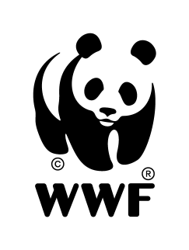
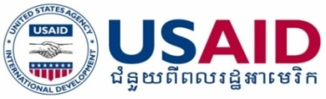

Terms of Reference (ToR)

Consultancy

for

End Line Survey to Assess Knowledge, Attitude, Practices of Target Beneficiaries toward Environmental Protection and Biodiversity Conservation

1. Background of consultancy assignment/project

The USAID Wildlife Sanctuary Support Program seeks to conserve forests and biodiversity, and promote inclusive, sustainable management of the Srepok Wildlife Sanctuary (SWS) and Phnom Prich Wildlife Sanctuary (PPWS) and their extended landscapes in Cambodia’s Eastern Plains Landscape (EPL), which is one of the largest intact blocks of forest in Southeast Asia and is internationally recognized as a priority site for conservation due to its biodiversity and ability to sustain an array of globally and regionally threatened species. The Project aims to address key threats to the landscape resulting from weak governance and land-use planning, low level of local community understanding of environmental protection and biodiversity conservation, coupled with a lack of capacity and resources to address illegal poaching, logging, and land clearing, leading to significant biodiversity loss, and degradation of forest and freshwater ecosystems services. One of the Project’s objectives is to improve environmental knowledge, attitude and practices (KAP) among the target beneficiaries who are forest dependants living in and around PPWS and SWS and their extended landscapes. .

In March 2019, the Project commissioned a consultant to conduct a feasibility study on the educational approach through a media app (mobile phone) and assess KAP among those intended beneficiaries on biodiversity protection and conservation. Key findings of the study have revealed that majority of people living in the target communities have a low level of education, 90% have not completed lower secondary school, and only 4% have up to upper secondary level. They generally have poor or very poor understanding of environmental protection and biodiversity conservation. The majority of them (64%) have not even ever heard about community protected areas (CPA) and only a small proportion of them who are CPA member could recall the key roles of a CPA. Only 9% of them possess a high level of understanding on environmental protection and biodiversity conservation. In general, they have many negative attitudes or perceptions toward the environment and biodiversity protection and conservation.

Based on the key findings of the study, the Project has carried out different environmental education interventions to change KAP of the target beneficiaries, including training of trainers for local environmental educators, in-person training and awareness; dissemination of key environmental messages through mobile phone hotlines and loud speakers, pagoda gatherings, and evening environmental film screening sessions. In 2020, the Project seeks to recruit a consultant to conduct an end line KAP survey to measure changes in KAP of the same target beneficiaries.

2. Objective of the consultancy

By comparing with the KAP baseline survey results in 2019, the consultant will conduct an end line KAP survey to measure the following changes.

- A high level of understanding on environmental protection and biodiversity conservation among the same target beneficiaries;
- Level of understanding on environmental protection and biodiversity conservation among the same target beneficiaries by gender and age group; and
- Attitudes or perceptions of the same target beneficiaries towards environmental protection and biodiversity conservation.
3. Scope of work/Major responsibility

Upon the confirmation of the assignment, the consultant will be responsible for the following:

- Review the existing KAP baseline survey method and questionnaires and modify them to fit with the end line KAP survey objectives in consultation with the Project’s team;
- Conduct a field test using the modified questionnaires and improve them if necessary;
- Enumerate data collectors and collect data using the agreed method(s), sample sizes, tool(s), and questionnaires;
- Enter and analyze data based on the objectives of end line KAP survey;
- Present the key findings to the Project team;
- Draft the assignment report in English and submit to the Project team for comments; and
- Submit the final report with key findings, lessons learned and recommendations on how the Project and/or WWF EPL should move forward in its environmental education strategy.
4. Requirements

- Bachelor or Master decree in environment, natural resources management, or social science;
- Knowledge of designing and conducting relevant researches;
- Experience of environmental education;
- Very good facilitation and communication skills;
- Very good knowledge and experience in data collection, analysis, and reporting.
5. Way forward for the KAP end line study

The consultant will submit the proposal to WWF Cambodia for the selection. The application should be included: 1). Letter of interest and CV; 2). Propose KAP survey methodology, and 3). Work plan and budget to jobwwfcam@wwf.org.kh with the subject line: Consultancy for end line KAP survey.

