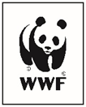
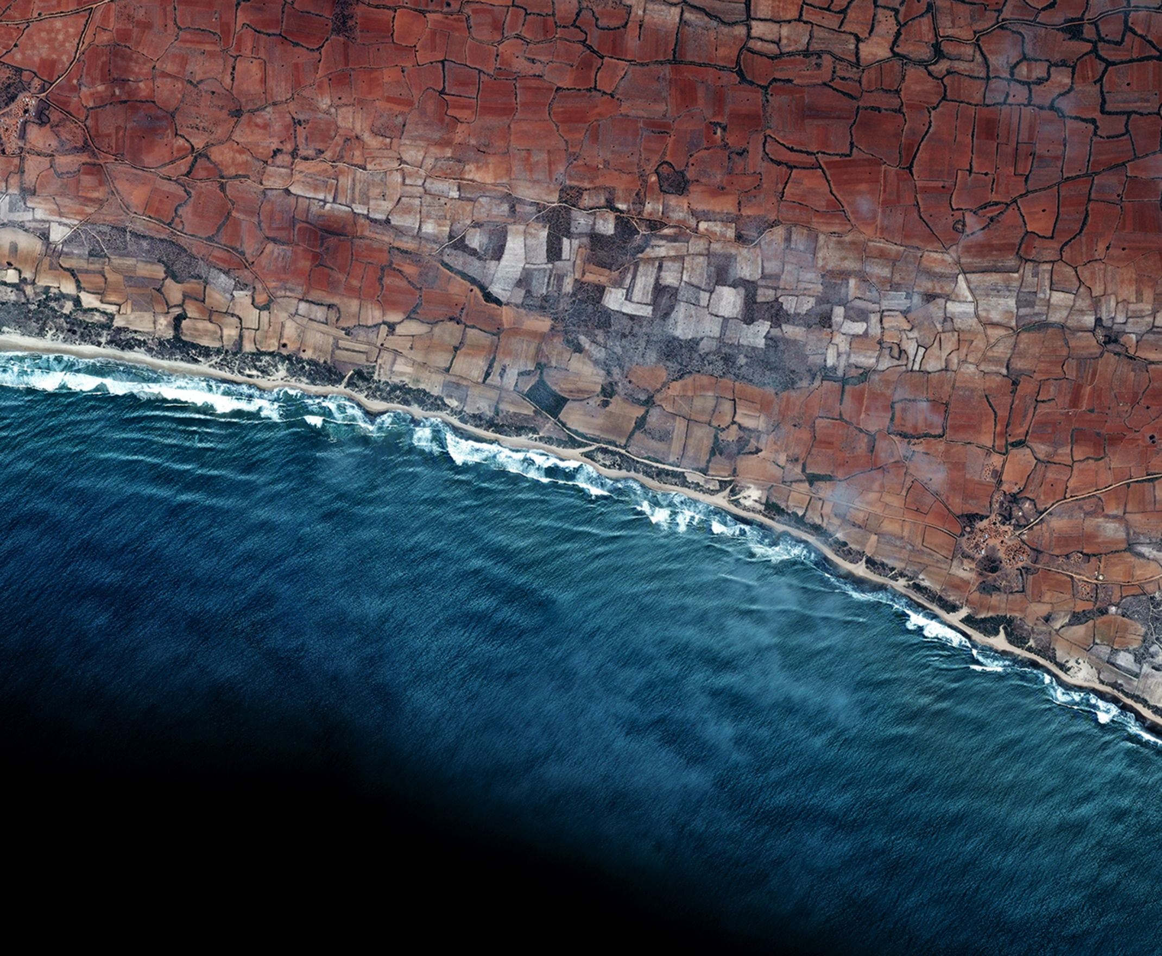
SOCIOECONOMIC BASELINE REPORT 2016-17
REHRI, IBRAHIM HYDERI, KAKAPIR.

Contents
Introduction 3

Foreword by WWF – Pakistan 5

Survey Methodology, Survey Dates, and Questionnaire Design 6

Area Profile: Rehri 7

Area Profile: Ibrahim Hyderi 9

Area Profile: Kakapir 11

Fishery Targets 13

Post-Harvest Strategies 15

Spending habits 17

Amenities and Alternate Energy Sources 18

Foreword by WWF – Pakistan

With the modern global eco-system throwing up unique challenges for conservationists, the World Wide Fund for Nature Pakistan (WWF – Pakistan) stands proud of its ability to create unique and dynamic solutions to rise to challenges ranging from specie protection, to climate resilience, to ensuring sustainable livelihoods for those who depend on the ecology for subsistence. With its inimitable position in the field, in 2016, WWF-Pakistan partnered with Engro Foundation, Pakistan to undertake a Community Development & Fishery Improvement Partnership.
Along the coast of Sindh and Balochistan; fishing is often the only source of sustenance and livelihood available to communities. Unfortunately, over the last decade, a steady decline in fish populations- due to excessive by-catch, post-harvest losses, and over fishing- has led to the economic stagnation of our coastal communities. And while local fishers have noted reduced catches, a continued collapse of fish populations could potentially devastate these communities and leave them in famine and abject poverty
The WWF and Engro share a common vision aimed towards community building, safeguarding the environment, and enhancing livelihoods across Pakistan. It is with this ambition in mind that the WWF and Engro have committed to a partnership that will see a collaborative project aimed at the development of three Union Council’s in Karachi City; Maripur, Rehri, and Ibrahim Hydri- a total population of 324,000. We intend to improve fishing practices so bycatch and post-harvest losses are reduced; while simultaneously ensuring transparency so fishermen do not catch fish illegally, which has long added stress to fish populations. A continued collapse of fish populations could potentially devastate these communities and leave them in famine and abject poverty.
This report has been designed as an output of our socioeconomic baseline survey in our target areas. Through it, we look to assess the state of fishery stocks in our areas so we may implement specifically designed initiatives that address the gaps existent in the practices of our beneficiaries. We look to understand their economic standing over the course of a year, the assets at their disposal, as well as their reliance on energy. Following this report, we shall aim to:
a) Provide practices for more efficient fishing, leading to fewer fish losses and higher profit margins.
b) Provide alternates to fire fuels (such as wood) to reduce economic, health and environmental impacts.
c) Distribute equipment to ensure more efficient fisheries.
Ali Dehlavi,
Regional Director, Sindh and Balochistan,
WWF-Pakistan.

Introduction

The World Wide Fund for Nature – Pakistan’s (WWF-P’s) Sustainable Fisheries Entrepreneurship: A Citizen Based Approach to Saving Pakistan’s Unique Marine Environment project envisages to develop sustainable fisheries and ancillary industries along the coasts of Sindh and Balochistan. WWF-Pakistan, with support from Engro aims to direct its efforts at three union councils in the fastest growing urban center in the world, (Karachi, Pakistan). Within these union council’s, WWF-P will initiate partnerships with local fisher groups, fisheries departments and the private sector, with the desire to support and cultivate improved fisheries management. Furthermore, the project looks to introduce alternate livelihoods, as well as more environmentally friendly practices within its target region. All inclusive, the program will focus on community mobilization, livelihood enhancement, promotion of alternate energy, environmental awareness, and marine research.
The coastline of Pakistan runs over 1000 kilometers of largely un-spoilt marine habitat (barring Karachi) with an Exclusive Economic Zone of approximately of 250,000 km2. The stretch directly supports the livelihoods of approximately 300,000 villagers spread across 90 hamlets and settlements and indirectly 700,000 people are associated with ancillary industries. Our project targets three Union councils in Karachi city: Maripur (inclusive of Kakapir village, population estimate: 74,000), Ibrahim Hyderi (Fishing colony with population estimate: 150,000), and Rehri village (inclusive of Lad basti, Chashma Goth and Razaqabad settlements, fishing colony with population estimate: 100,000). The following report will aim to analyze the socioeconomic realities of our target areas.
The target union councils predominantly depend on fisheries as the main livelihood resource, they also face severe power outage problems due to a) limited capacity for energy production, and b) high dependence on costly imported fossil fuels, perpetuating the circular debt crippling the energy sector and contributing to global GHG emissions. The communities in these areas are thus directly dependent on natural resources for energy, and livelihood purposes. In order to resolve these issues, there is a dire need to focus on both ecological and socio-economic aspects of the fishery. Through the Sustainable Fisheries Entrepreneurship: A Citizen Based Approach to Saving Pakistan’s Unique Marine Environment project, WWF-Pakistan will focus on two major components; i) developing sustainable fisheries, and ii) regional cooperation.
As this report covers our socio-economic baseline survey conducted in our three target locations, we will limit ourselves to first component set out above – to develop sustainable fisheries. In order to reduce the stress on local marine stocks, it is imperative to assess fisher practices and to impart positive practices and techniques in order to maximize the potential price of their catch, while reducing their need to “catch more”. The survey also looks to explore whether avenues for alternate livelihoods exist within our target areas. Furthermore, with sources of energy being inconsistent in our target regions, and alternates leading to the degradation of locals’ health, as well as the environment – WWF-Pakistan and Engro would also like to assess the potential for renewable forms of energy in the area’s – particularly in the form of small, pay as you go solar energy units.

Survey Methodology, Survey Dates, and Questionnaire Design

WWF-Pakistan and Engro’s Sustainable Fisheries Entrepreneurship sampling strategy is designed to extract a representative sample of our three research sites, so as to ensure a consistency of estimations with our calculations.
The survey as a whole comprised of 100 households, with samples being divided between the three UC’s based on population demographics according to proportionality. Our field enumerators employed a method of systematic sampling whereby every 10th household was surveyed. The span of the survey covered 14 moholla’s in Ibrahim Hyderi, while 8 and 12 mohalla’s were surveyed in Rehri, 12 at Kakpir respectively. This provides us with the most representative cross-section of the populations of our target areas. A random sample of moholla’s (clusters) was selected within each union council, wherein sampling was proportional to. No less than 8 moholla’s, and up to 14 moholla’s were selected.
In each mohalla, the 10th household was surveyed under a systematic sampling method. As a wide number of moholla’s were surveyed, bias was minimized as a range of relatively affluent and poorer neighbourhoods were surveyed.
Baseline surveys were conducted as follows: Kakapir (19th-21st October, 2016), Rehri (26th-28th October, 2016), and Ibrahim Hyderi (1st-4th November, 2016).
Teams of both male and female enumerators were trained by WWF-Pakistan staff. Key training items covered included: familiarity with survey instrument modules, enumerator data entry protocols, methods for corroborating the validity of respondents’ answers, and techniques to facilitate the task of data entry operators.
A reconnaissance survey and pilot testing of the questionnaire was conducted on 18th October, 2016at Kakapir. This was overseen by programme researcher.
The survey instrument design includes three basic modules: (a) profile of household members; (b) their access to social infrastructure and perceptions on environmental, social and economic challenges; (c) sources of income in both disaggregated and aggregated forms; (d) fishing assets and practices; and (e) energy consumption, sources, and the disaggregated expenditure on energy.

The questionnaire design includes questions on climate change adaptation to provide a baseline, in particular, for: assessment of existing adaptation measures, if any, and the demand/need for help with adaptation.
Table 1 The sample
Survey sites | Sample Size | Population | Percentage of population
Rehri | 30 | 100,000 | 0.030
Kakapir | 30 | 74,000 | 0.040
IbrahimHyderi | 40 | 150,000 | 0.026

Area Profile: Rehri

Rehri village consists seventeen mohalla’s, with the size of eachranging from 250 to 2000 households. Rehri lies to the south-east of Karachi, and is connected to the city through a poorly maintained road. The village hosts over 100,000 residents, and fishing makes up of almost the entirely the economic activity of the village. The major source of income for community is fishing, while other professions, such as laborers, small shopkeepers, and steet cart fruit and vegetable sellers.
Income Analysis
In this section we estimate daily per capita income at Rehri (2016), based on methodology described in section 2.2 above. This section therefore does not repeat in subsequent site-specific reporting.
Pakistan’s last estimated poverty line (2007-08) is PKR 948.47 per capita per month (Economic Survey of Pakistan, 2009-10). It is calorie-based and reflects expenditure on calorie intake of 2,350 calories per adult equivalent per day, along with consumption expenditure on non-food items. The next poverty-line will be adjusted at the time of estimation to account for inflationary impacts in intervening years. Similarly, the latest international poverty line estimated by the United Nations Statistical Division, the World Bank and the University of Pennsylvania, using 2005 purchasing power parity, is USD 1.25 per person per day. In terms of this headcount index, between 1981 and 2005, the proportion of Pakistanis living below USD 1.25 declined from 73% to 23%. Though this still leaves Pakistan lagging behind the MDG indicator of 13%.
On Season
In order to draw a deeper understanding of incomes generated in the research areas, the survey instrument separately accounted for seasonal income and off season income. For the purposes of our survey, seasons are assumed to last September through April, while between May and August, fishing is assumed to be off season and little to no fishing activity takes place.
During the seasonal months, the average monthly income is estimated at approximately 20,400 rupees a month. This comes out to just a shade under $195 per month, or PKR680/$6.5 per day per capita. 66% of the population of Rehri, however, earns less than the mean we have calculated.

Table 2: Rehri, income distribution during fishing season - 2016

Off season Income
As discussed previously, outside of fishing season, income generated in the villages decreases substantially. In Rehri, the per capita per month falls to PKR 11,290 from PKR 20,400 during the season. This represents a drop of nearly 50%. From the table below, it is further observable that during off seasons, Less than 20% residents earn above the mean seasonal income.

Table 3: Rehri, income distribution off season - 2016

Area Profile: Ibrahim Hyderi

Ibrahim Hydri, formerly Machi Mian is a typical fishermen village south of Karachi. The 400 years old community has an approximate population of 150,000 and is one of the most populous villages in the Sindh province. It consists of 52 mohalla’s, and 90% of the population of the village are either fishermen, or work in fishing-related activities. The remaining 10% work as laborers, shopkeepers, and street vendors.
Income Analysis
In this section we estimate daily per capita income at Ibrahim Hyderi (2016), based on methodology described in the section above.
On Season
Compared to Rehri, Ibrahim Hyderi is a larger village and fishing is a more commercial exercise. We learnt during our research that 77.5% of respondents in the village worked as fishermen on boats that did not belong to them. This was substantially higher than the 49.7% and 33.3% of instances in Rehri and Kakapir respectively. With a greater emphasis on fishing as a commercial, waged labour – it is unsurprising then that the mean monthly and daily income in Ibrahim Hyderi dring the fishing season is significantly lower than that of Rehri. The monthly average wage falls at PKR 13,710, or approximately $130. Daily wage falls at a PKR 457, or slightly above $4.30.

Table 4 Percentage of on season earners by income bracket, Rehri and Ibrahim Hyderi, 2016

Off season
With a large percentage of workers in Ibrahim Hyderi working as waged fishers on others boats, the impact of a lack of fish during the off season is clearly distinguishable.
More individuals earn below the national poverty line in Ibrahim Hyderi for a significant part of the year than any other of our target areas. Furthermore, there is a severe lack of available work as well with approximately 15% of our sample stating they often would go through the summer months without work.
Table 5 Percentage of off season earners by income bracket, Rehri and Ibrahim Hyderi, 2016

Area Profile: Kakapir

Kakapir is situated 15 km to the southwest of Karachi at Sandspit, Hawksbay. This is a small coastal village with backwaters to its north, and the coast to its south. The backwaters are covered in a thicket of mangroves – Part of the mangrove forests essential to the ecology of coastal Pakistan. The Naee Nar channel, which extends out from Kakapir, is used for small scale fishing activities. The area comprises of tidal lagoons, intertidal mudflats and salt pans. The village consists of around 300 households with a population of about 2300, and is part of the larger Maripur union council. The village economy is primarily based on fishing, as majority of the population is engaged in activities related to fishing. Almost every household owns one or two small boats or work on others boats.

Income Analysis
On Season
As has been highlighted above – at 66.6% of the fishermen surveyed at Kakapir owned their own personal boats, which they utilize for fishing. This indicates a lower instances of waged labour in the village. When this is factored in, unsurprisingly, Kakapir has the highest mean monthly and daily income on our research areas. The Average monthly income during the season stands at PKR 22,916 - or $219. The daily mean wage, meanwhile, stands at PKR 764 – or $7.30. As can be seen from the table below, Kakapir has a greater number of above-mean earners than our other two study areas.

Table 6 Percentage of on season earners by income bracket, Rehri, Ibrahim Hyderi, and Kakapir 2016

Off season
As with Rehri and Ibrahim Hyderi, during the off season, incomes suffer significantly, but, as in the case of seasonal incomes, Kakapir fares the best of our three research areas. Mean monthly income during the off season falls at PKR 13833 – or $ 132. While the daily mean income comes to PKR 461 - or $4.40.

Table 7 Percentage of off season earners by income bracket, Rehri and Ibrahim Hyderi, 2016

Fishery Targets

Each of our three research areas are highly dependent on the commercial catch and sale of fish as a means of livelihood. As local competition is always stiff, every season invariably becomes a race to catch a high quantity of fish. This has significantly increased the stress on the local fish stocks – As recently as 2003, Pakistan’s fisheries have faced a collapse due to a drastic fall in the stocks present within our territorial waters. Our entire sample has also stated that fish stocks have significantly reduced for their catch of choice, and a greater effort in now needed for the same quantity of catch as previously. The following section will attempt to analyze the fish species that are targeted within our research area. We will also specifically be concentrating on post-harvest tools of processing fish once caught, as a higher quality of caught fish can be sold at higher prices than a larger quantity of fish.

Major target species across the three research areas
Though the fisheries within our target areas did not necessarily limit themselves to the catch of specific species’ – they did have target species that they would set out with specific intent to catch. The following chart details the most targeted species, as a percentage of the fisheries of all three research areas combined. Prawn and shrimp, combine to represent 42% of the fisheries main target catch.

Table 8 Fishery: Primary target species

Once fish are caught, however, they need to be adequately maintained and/or preserved until they are sold. 80% and 70% of the fishermen at Ibrahim Hyderi and Rehri respectively sell their entire catch to middlemen. Meanwhile, at Kakapir, over 70% of fishermen sell over half their catch to middlemen. As there are little to no checks on middlemen, they ultimately control prices, and can use the slightest signs of damage on fish to reduce prices drastically. 90% of all respondents surveyed, and 90% or above at each individual research area noted that the prices of their catch were reduced by middlemen due to damage regularly. This indicates a substantial loss of income generation for local fishermen. Over-fishing is an observable outcome of the loss of income, as fishermen race to catch more. Theoretically, an analysis of the post-harvest processes available to fishermen, and an improvement of those processes should lead to a lower instance of spoilt catch; leading to higher income generation, consequentially reducing the risk of overfishing.

Table 9 Percentage of catch considered “spoilt” by village per trip.

Post-Harvest Strategies

Post-harvest processes may be applied to caught fish on board the vessel immediately after they are caught, or may be applied once the boat has landed at the coast. Due to the lengthy duration of a fishing vessel at sea, combined with the high temperatures of coastal Pakistan, it is ensure to protect fish from the elements as soon as they are caught. The most effective method of protecting fish in such a manner is by storing them in cold storage on board the vessel (such as an ice box). Ice boxes are the most commonly found method of post-harvest preservation in our research areas. However, due to costs, most fishermen are unable to afford ice box units.
Our survey instrument for the research areas attempts to identify the gap with regards to the presence of ice boxes within the fisher community. Approximately 17% of the combined fisheries of the target areas lack access ice boxes. With the number standing at 33% in Ibrahim Hyderi – the poorest of our study areas – intervention in this area could substantially boost incomes, as well as reduce stress on fish stocks.
Instances of ownership of iceboxes are detailed below. We have compared the presence of iceboxes to boat ownership to highlight the lack of ability to protect catch even within those who own boats oftentimes. Kakapir sees the lowest prevelence of iceboxes, despite a high percentage of boat ownership. Thusly, our survey indicates that Kakapir requires the most attention – however; instances of ownership of iceboxes at Ibrahim Hyderi are also low – however, a lack of boat ownership may go far in explaining that.

Awareness of methods of post-harvest such as drying fish on racks and applying salt are known, but not very commonly, with only 35% of our combined sample having not have applied either of these methods. However, with at times lengthy hold time before the catch is sold, an introduction of such methods on a larger scale can significantly boost the fisheries in the areas.
Furthermore 60%, 77% and 85% of the sample at Rehri, Kakapir and Ibrahim Hyderi respectively felt that technical assistance in the area was inadequate and any issues were cumbersome to resolve. 51% of the total sample also felt materials were either entirely unavailable, or extremely difficult to access with regards to maintenance and repair work aboard their vessels.

Spending habits

It is essential to note here that indicators do exist that can help us understand fully the capacity for improvement within fisheries. It is interesting then that 49% of our total sample re-invests earnings into improving fishing operations. Breaking this into representations of each target area, with 25% of the fishers dedicating income to operation maintainance , Ibrahim Hyderi holds the lowest instance of investment into ones’ own operations. This may be linked to either a) the generally rampant poverty in the area, or b) the nature of a larger pool of employed workers at Ibrahim Hyderi. Regardless, the benefits of investing in one’s own operations is a best practice that can be expounded upon and introduced through our project interventions.
Beyond operation maintenance, it is important to understand other monetary practices within the study areas. A combined 35% of our sample felt that they succeeded at the end of the month in ensuring some form of savings. Our research further indicates that savings are not linked to the amount of income. Low bracket earners are just as likely to manage to save as high bracket earners according to our data; which indicates a need for greater education and understandings of the benefits that can accrue from monthly savings. All of the respondents who managed to accumulate monthly savings looked forward to the possibility of alternate livelihoods being introduced – However a lack of exposure and education means they see little scope beyond opening a shop.

Amenities and Alternate Energy Sources

Table 10 Percentage of households with access to electricity, gas, and sewage

As the graph above indicates, apart from Kakapir, where sewage lines have not been drawn, basic access to electricity, gas and sanitation exists among all our study areas. However, it is beyond these figures that reality persists. As per our research – though connections to electric and gas lines does exist; the provision of both is inconsistent and inadequate with all respondents agreeing that neither were provided for more than a couple hours a day. As such, the people of the three villages spend heavily on alternate means of fuel; ranging from firewood for heat and cooking, to candles for lightening. Alternates are both heavy on the health (burning of fuelwoods and candles), as well as the pocket for locals. Referencing to the idea of a lack of electricity being heavy on the pockets – locals in our research areas pay shop-owners to charge their cell phones due to a lack of electricity at homes. This is just one of the many expenses locals could cut down on while embarking on more sustainable lifestyles!
Table 11 Instances of use of alternate sources of energy

Of the alternate sources of fuel utilized, candles are the most common; used by 76% of our sample over the three study areas. 48% of our sample also used firewood, while 11% turned to kerosene and charcoal. The following chart breaks down the average price per person for those who use alternate sources of fuel in our three research areas.
Though dependence of firewood, kerosene and charcoal is low, we can see the significant cost involved for those who do opt for them. Candles on the other hand are much more regularly used and still even in the lowest instance of their use (i.e, Kakapir), they are a significant economic cost.

Table 12 Average cost per household for households that use alternate fuels

The cornerstone of our project with Engro is the provision of sources of alternate energy to locals. This is to largely be achieved through the delivery of small solar energy units to local beneficiaries. These units provide the power to run small lights, along with phone chargers and optional additions of fans and televisions. Our survey instrument was designed in a manner whereby it would initially attempt to highlight the money spent on alternate energy sources by locals through a series of questions. The results of these questions manifest themselves in the table above. The survey then attempts to illicit from respondents whether they would be interested in paying sums similar to their expenses on alternate fuels in order to gain access to a solar unit. Their responses have been exhibited in the tables below.

PKR 1500 or more | PKR 1000-1499 | PKR 500-999 | PKR1-499 | PKR 0
39% | 41% | 7% | 3% | 8%
Table 13 Percentage of sample and price willing to pay to install pay-as-you-go solar units

PKR 800+ | PKR 500-799 | PKR 400-499 | PKR 300-399 | PKR 0-299 | PKR 0
3% | 24% | 12% | 26% | 27% | 8%
Table 13 Percentage of sample and monthly fees willing to pay for pay-as-you-go solar units

A total of 39% of our respondents, in addition to the answers represented in the above tables stated they were interested in renting a solar unit at the market price of Rs 499 that was quoted to them. The locals are all well versed with cell-phone credit loading methods and therefore can easily pay the due rent at their local easy-paisa store.

A scope beyond just solar energy however too does exist in our target regions. In Kakapir in particular, locals have built septic tanks in order to overcome the lack of sanitation. These septic tanks can, under future projects be linked to underground biogas plants to provide communal energy. This however requires synergizing around the community in order to ensure equal participation in the running and maintenance of the tanks. This was identified as a major hurdle during our survey as a majority believed people would not fulfill responsibilities such as adding waste to the tanks.

Venue: Village Grammar School, Ibrahim Hyderi
Date: 28th December, 2016
Activities: Community Learning Workshop and Green Fix (Cleaning drive, wall painting and platation drive)

Please feel free to get in touch incase any further details are required.

Thanks and regards,

