Zero-Snaring in Cambodia’s Protected Areas Campaign Launch
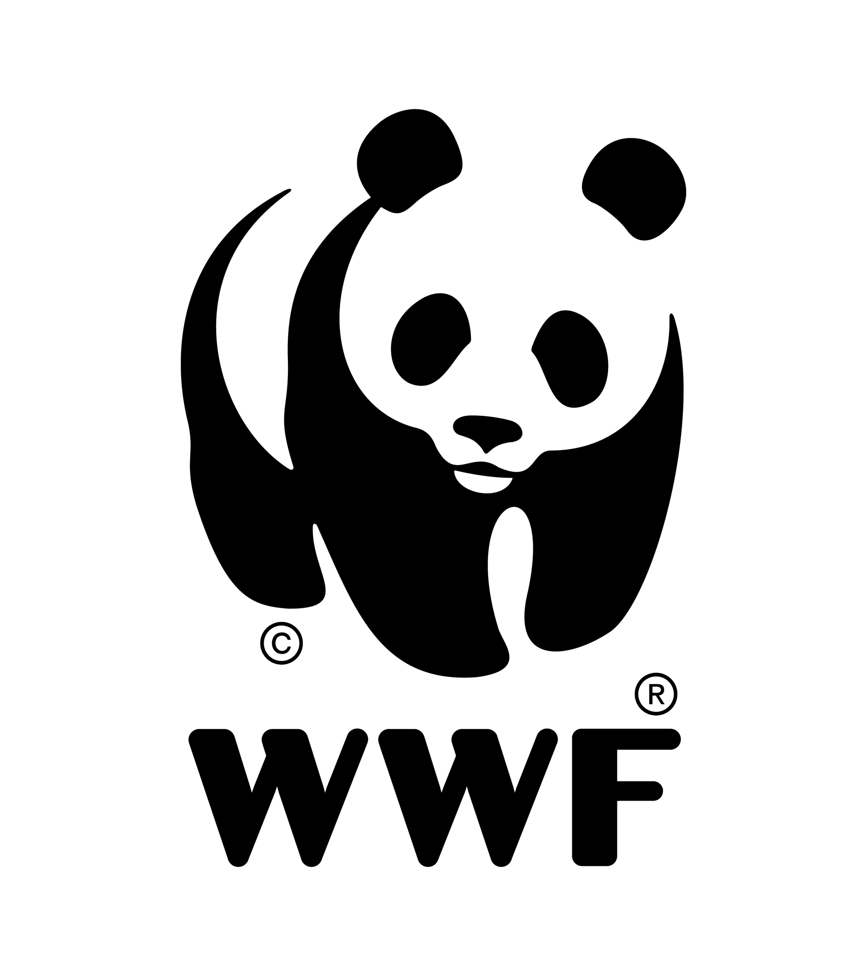
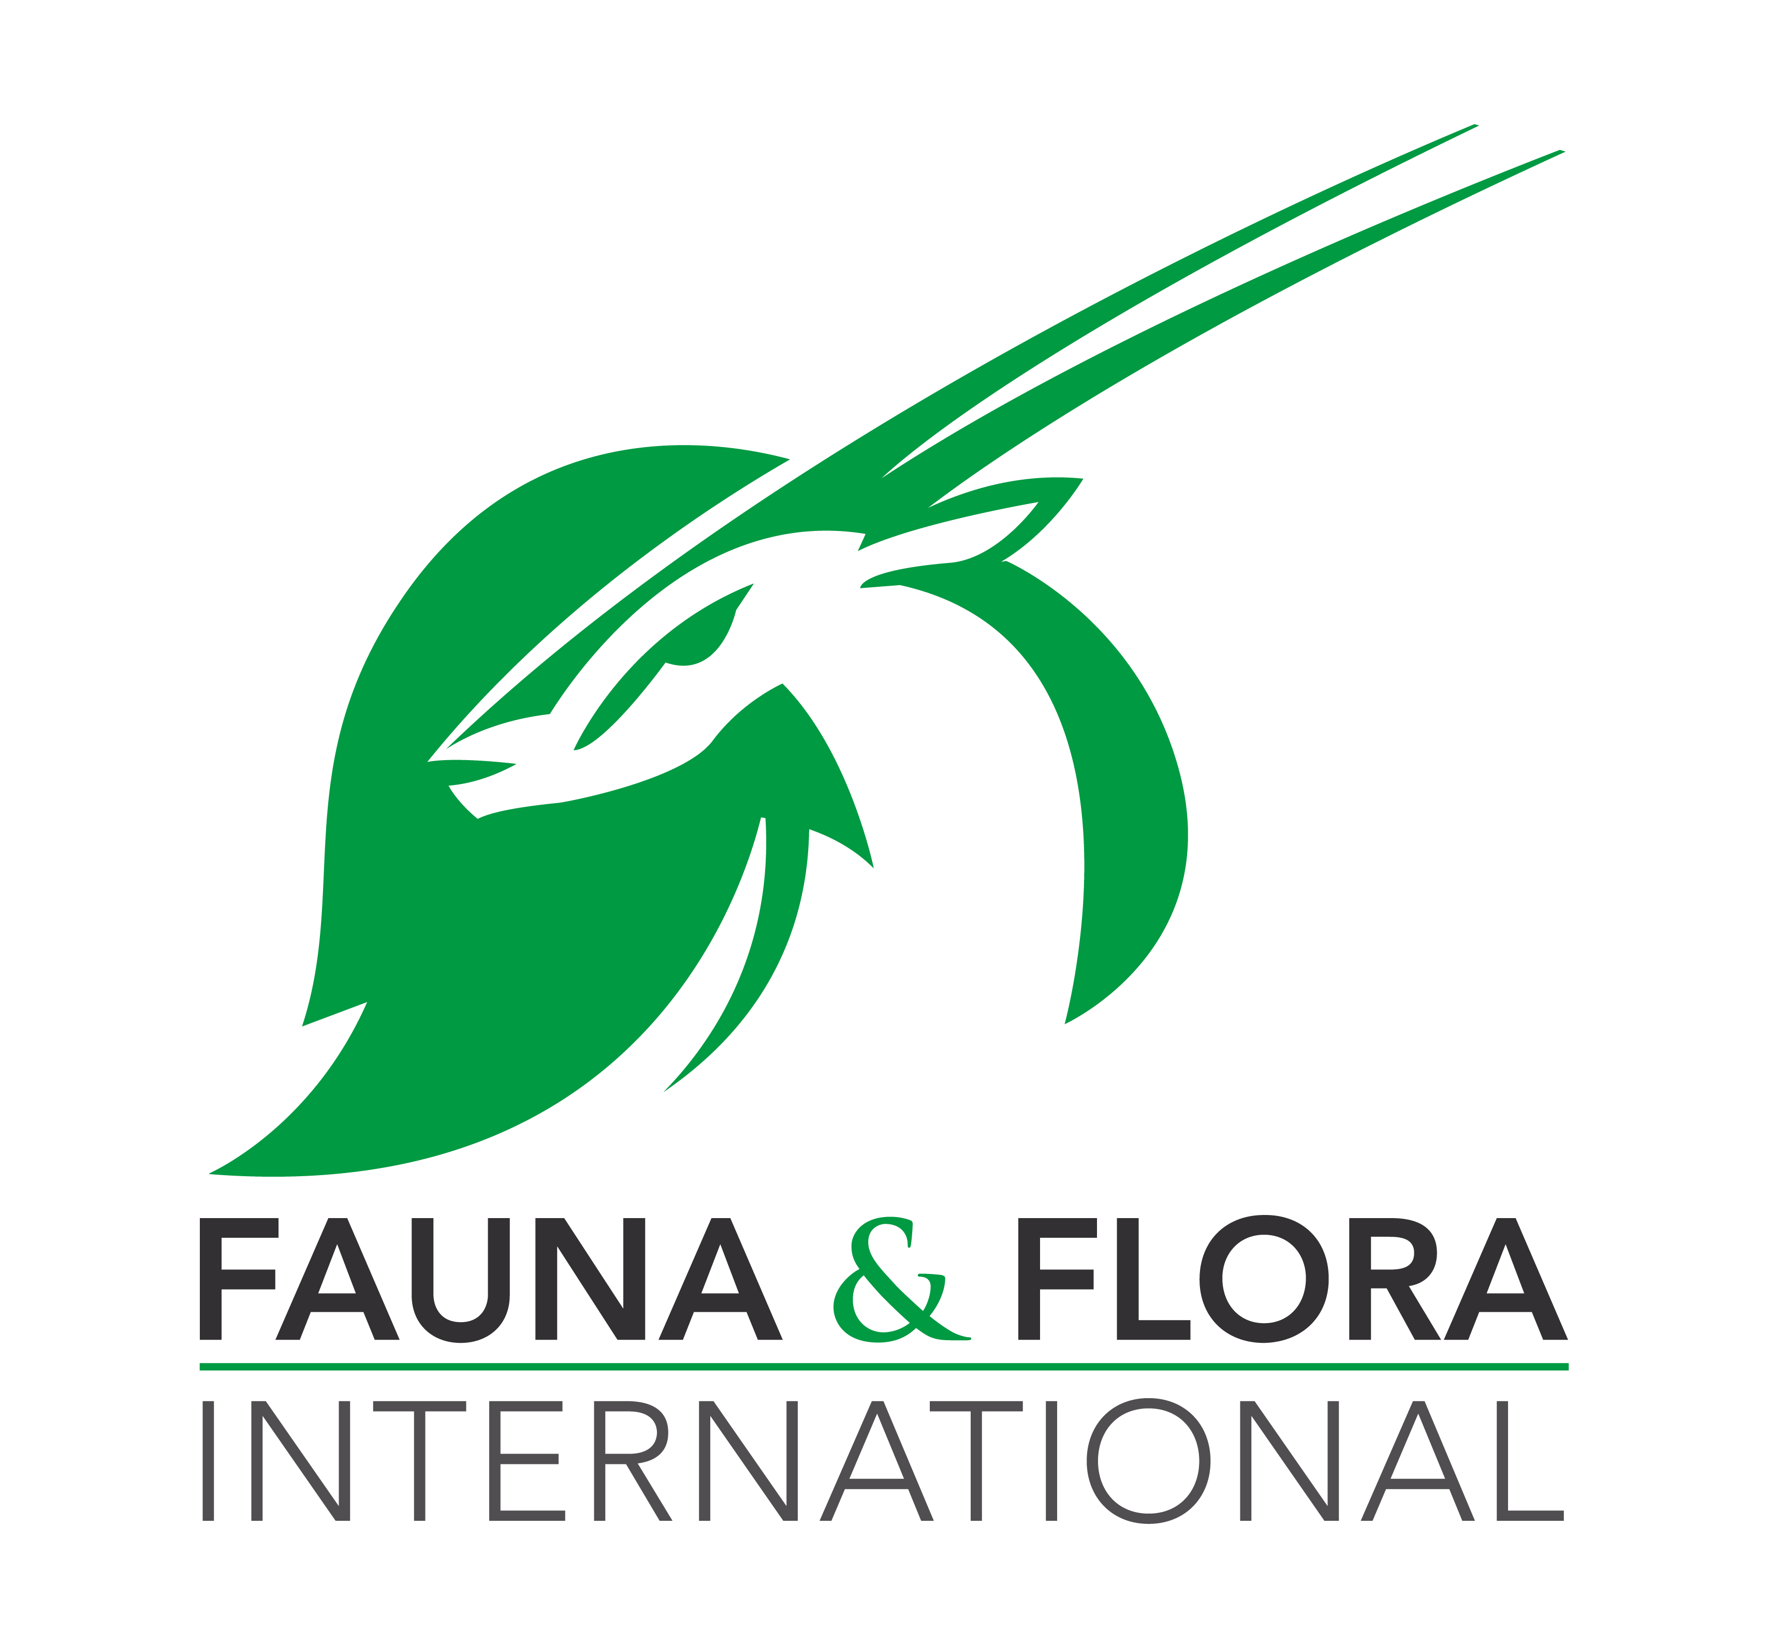
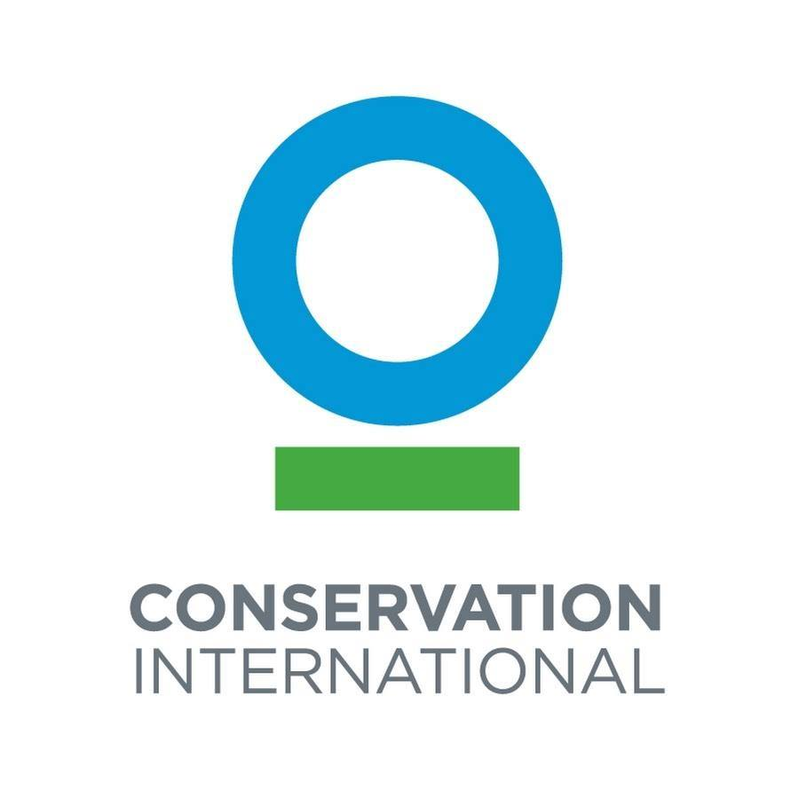
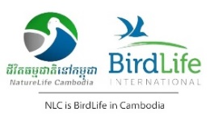

Joint Media Release:
Government and conservation organizations commit to ending the snaring crisis in Cambodia

Phnom Penh, 3 March 2022 - Cambodia’s wildlife is at high risk due to a poaching and snaring crisis fueled by the consumption and illegal trade in wildlife. If immediate steps are not taken, Cambodia risks losing its globally irreplaceable wildlife in the future. To address this crisis a coalition of government ministries and international conservation organizations came together today to launch the Zero-Snaring in Cambodia’s Protected Areas campaign. The goal of the campaign is to eradicate all types of snaring in Cambodia’s protected areas.
The Ministry of Environment and its partners removed 61,611 snares from 72 protected areas and biodiversity corridors across Cambodia in 2021. In average, a total of more than 40,000 snares were removed per year from the protected areas.
The snaring crisis in Cambodia is not unique. According to the WWF’s 2020 report entitled Silence of the Snares: Southeast Asia's Snaring Crisis, millions of snares are thought to be active at any given moment in the protected areas of other countries in the region such as in Laos, Viet Nam, Malaysia, and Indonesia.
“Transformative and multi-disciplinary actions are necessary to end the snaring crisis and illegal wildlife trade across Cambodia,” said His Excellency Neth Pheaktra, Secretary of State to the Ministry of Environment, as he led today’s launch event.

From tortoises to elephants to monkeys and birds, snares kill indiscriminately. Wildlife languishes for days before dying from their injuries, lack of water, or starvation. Snares are a major contributor towards the functional extinction of tiger in Cambodia and the rapid decline of the Indochinese leopard. Cambodia’s guar, banteng, Sambar deer, and other ungulates are threatened with local extinction due to snaring. Critically endangered vulture and Giant Ibis are also the victim of snaring and poisoning.

“These rudimentary traps, often made inexpensively from wire or cable and set in huge numbers, are indiscriminate killers, trapping or wounding any ground dwelling animal that happens upon them, including globally significant animal species that the Royal Government and partners have been working actively to protect,” said His Excellency Neth Pheaktra.
Snares not only empty forests of wildlife, but they also increase the risk transmission of zoonotic diseases from wildlife to humans. Those who set the snares, sell and consume wild meat are all at risk.
Today’s campaign launch represents a unique opportunity for key Government actors to examine ways to counter this devastating threat to Cambodia’s wildlife and public health, and to bring an end to snaring in protected areas. Representatives from the Ministry of the Interior, Ministry of Environment, Ministry of Health, Ministry of Tourism, Ministry of Agriculture, Forestry and Fisheries, Ministry of Commerce, Ministry of Justice, Ministry of Education, Youth and Sport, as well as representatives of provincial government agencies all attended the campaign launch and committed to supporting the campaign goal as a matter of national urgency.

“Today we made a commitment to fight for the future of Cambodia’s people and wildlife,” said Mr. Nob Sothunvisoth, Director of Department Research and Training of the Ministry of Justice. “Snares and the wildlife trade pose a grave threat to all of our health, be it environmental, physical or financial. The coming together of all of the relevant ministries demonstrates our collective resolve to combat biodiversity loss, and prevent possible future pandemics at the source of the problem.”

Dr. Yi Sengdoeurn, Deputy Director of Communicable Disease Control Department of the Ministry of Health, said that OneHealth has now become more important in recent years. “The One Health approach improves health outcomes by understanding and addressing the interactions between people, animals, and our environment. Implementing One Health measures is important for protecting public health from future zoonotic risks,” he said. “We must work together to prevent the purchase, sale, transport and consumption of wildlife species which are of high risk for zoonotic disease transmission,” he added.

International non-governmental organizations including WWF, the Wildlife Conservation Society (WCS), Conservation International (CI), BirdLife, Fauna & Flora International (FFI), and Wild Earth Allies, all committed to supporting the campaign.

“The time for our collective action is now to urgently adopt unprecedented and innovative solutions to address the root causes of the wildlife decline and trade, and to put nature on the path to recovery,” said Mr. Teak Seng, Country Director of WWF-Cambodia.

"We are committed to supporting the Government’s efforts to take immediate and decisive action to prevent wildlife snaring, through our interventions that encourage reductions in snaring and by improving the public’s understanding of the devastating consequences this practice has for Cambodia's wildlife and in turn our health," said Dr. Ken Sereyrotha, WCS Cambodia Country Program Director.

Following today’s campaign launch in Phnom Penh, provincial level rallies will be held to ensure that the public is aware of the threats posed by snaring; that effective law enforcement is carried out in protected areas; that demand for wild meat is reduced; and that provincial law enforcement agencies are working together to combat illegal snaring and illegal wildlife trade.

“Simply removing snares is no longer enough. We must improve national and provincial law enforcement and strengthen cooperation to effectively deter against snaring, all while reducing the demand for wild meat that drives this pernicious behavior,” said Mr. Jeremy Parker, Director of Operations, Asia Pacific of FFI.

“It is not too late to make a difference, but only if we start now at every level to take immediate collective conservation actions for conserving forests and reversing biodiversity loss,” said Dr. Jackson Frechette, Greater Mekong Landscape Director of CI.

“We are advocating for better ways of managing, using and sharing natural resources to support sustainable development and create a space where human and nature can live in harmony,” said Mr. Tuy Sereivathana, Programme Director of Wild Earth Allies Cambodia.

Urgent action is needed to address this threat to wildlife, ecosystems and public health. More investment must be made in the effective management of protected areas and the conservation of wildlife and wild spaces.

“Now more than ever, we need to let public people know about the negative impact of eating bushmeat on their health, reaffirm our commitment to strengthen efforts to end the snaring crisis and combat the illegal trade in wildlife for the benefit of people and nature, both current and future generations,” said Mr. Bou Vorsak, CEO of NatureLife (BirdLife in Cambodia).

The Ministry of Environment calls on all people to stop consuming wild meat and all other wildlife products. “We urge all people across Cambodia to say no to wild meat and participate in conserving the Kingdom’s natural resources,” said His Excellency Neth Pheaktra.

It is expected that the campaign effort will lead to reviewing and amending relevant laws concerning penalty on the possession of snares and dogs in the protected areas, establishing a multi-agency law enforcement unit in charge of anti-wildlife crime at the provincial level, and adopting preventive measures issued by the World Health Organization in April 2021, on public health risks associated with the sale of live wild animals for food and bushmeat consumption.

-Ends-

For more information, please contact:
His Excellency Neth Pheaktra, Secretary of State to the Ministry of Environment
Mobile: 012 483 283

Or reach out to
The campaign’s secretariat
TEP Asnarith
Mobile: 012 957 919

Link to photos: https://bit.ly/3IHNGhW

